**HTML:**

Html stands Hypertext markup language

**Language:**

Language is nothing but a System of communication with his own conventions like words or signals.

In computer terminology language is nothing but a set of instructions which are used to communicate with the computer.

**Markup:**

Highlighting or editing the information is called as Markup.

**Hypertext:**

Hypertext is nothing but a text which is having hyperlinks. Here hyperlinks are used to navigating from one webpage to another webpage.

Html is web technology. And html is used to develop or design the websites. Html is developed in Tim Berner's lee in 1990. Before html to develop webpages we use a technology SGML (Standard Generalized Markup language). And Html is provided by W3C (World Wide Web Consortium) organization.

**Versions of html:**

**Version** **year**

HTML 1991

HTML 2.0 1995

HTML 3.2 1997

HTML 4.01 1999

XHTML 2000

HTML5 2014

**History of html:**

Since the early days of the web, there have been many versions of HTML:

**Version Year**

Tim BernersLee invented www 1989

Tim BernersLee invented HTML 1991

Dave Raggett drafted HTML+ 1993

HTML Working Group defined HTML 2.0 1995

W3C Recommended HTML 3.2 1997

W3C Recommended HTML 4.01 1999

W3C Recommended XHTML 1.0 2000

HTML5 WHATWG First Public Draft 2008

HTML5 WHATWG Living Standard 2012

HTML5 W3C Final Recommendation 2014

* Tim BernersLee invented the "World Wide Web" in 1989, and the Internet took off in

the 1990s.

* From 1991 to 1998, HTML developed from version 1 to version 4.
* In 2000, the World Wide Web Consortium (W3C) recommended XHTML 1.0.
* The XHTML syntax was strict, and the developers were forced to write valid and "wellformed" code.
* In 2004, WHATWG (Web Hypertext Application Technology Working Group) was formed in response to slow W3C development, and W3C's decision to close down the development of HTML, in favor of XHTML.
* WHATWG wanted to develop HTML, consistent with how the web was used, while being backward compatible with older versions of HTML.
* In the period 2004-2006,the WHATWG initiative gained support by the major browser

Vendors.

* In 2006, W3C announced that they would support WHATWG.
* In 2008, the first HTML5 public draft was released.
* In 2012, WHATWG and W3C decided on a separation:
* **WHATWG will develop HTML as a "Living Standard".**
* A living standard is never fully complete, but always updated and improved. New

features can be added, but old functionality cannot be removed.

* The WHATWG Living Standard was published in 2012, and is continuously updated.
* **W3C will develop a definitive HTML5 and XHTML5 standard**, as a "snapshot" of

WHATWG.

* The W3C HTML5 recommendation was released 28 October 2014.

**New HTML5 Elements**

**The most interesting new elements are:**

New semantic elements:

<header>, <footer>, <article>, and <section>.

New form control attributes:

number, date, time, calendar, and range.

New graphic elements:

<Svg> and <canvas>.

New multimedia elements:

<audio> and <video>.

**Website:**

Collection of webpages is called website.

(or)

It is place which is used to interlinking the webpages

**Webpage:**

Webpage is nothing but Hypertext Document.

Websites are classified into two types those are

1. Static Websites

2. Dynamic Websites

**Static websites:**

Collection of all static webpage is called as static website.

**Ex:**

Search Engines (like google,youtube) wikipedia

**Static webpage:**

It is a webpage which gives the same information for all the users at a particular point of time.

**Ex:**

Homepages of all the websites

**Dynamic Websites**

Collection of both static and dynamic webpages is called as dynamic websites.

**Ex:**

Gmail, irctc, redbus, flipkart, facebook,etc.,

**Dynamic Webpage:**

It is a webpage which gives different information for every individual user at a particular point of time.

**Ex:**

After login and before logout pages of every website.

**Web technology:**

Technique to interlinking the webpages is called as

Webtechnology.

1. server technology

2. Client technology

1. **Server Technology:**

Technique to take the request from the client and process the request and then sends response to the client is called as server technology.

Ex:

servlets,jsp,php,.net

1. **Client Technology:**

Technique to send the request to the servers and getting information from the servers is called as client technology.

**Ex:**

html,xhtml,etc.,

**Markup languages:**

These type of languages are used to developing the webpages. In markup languages we does not use any programming language concepts like variables, operators, control statements, etc.,

To represent anything in markup languages we use the Tags.

**In Html, the tags are classified into 5 types.**

1. Pre-defined tags
2. User-defined tags
3. Single Tags
4. Paired Tags
5. Nested Tags
6. **Pre-defined Tags:**

Pre-defined tags are already available, so we cannot to create and we can directly use the pre-defined tags

**Ex:** html, head, body

1. **User-defined Tags:**

These tags are not available so we can create and use the user defined tags

**Ex:** emp, stu, product

**Note:**

In html we cannot create any user defined tags we use predefined tags only.

1. **Single Tags:**

Single tags are also called as Inline tags. And in this single tag, starting tag and ending tag should be in the same tag. It is not possible to place any content inside the single tags.

**Syntax:**

<tagname/>

**Example:**

<br/>

<hr/>

<img/>

1. **Paired Tags:**

Paired tags are also called as blocked tags. In paired tags starting tag and ending tags are separated in different tags. And it is possible to place the contents inside the paired tag.

**Syntax:**

<tagname attributes events>

Contents

</tagname>

**Example:**

<marquee>

Contents

</marquee>

1. **Nested tag:**

Tags inside another tag are called as Nested tags.In nested tags outer tag must be paired tag and child tags are either paired tags or single tags.

**Syntax:**

<tagname>

<tagname\>

<tagname>

Contents

</tagname>

</tagname>

**Example:**

<html>

<head>

</head>

<body>

</body>

</html>

**Attributes:**

Properties of the tags is called as Attributes and which are used to provides the extra information about the tag to web browsers

**Syntax:**

attribute name=”attribute value”

In html attributes are classified into two types.

1. Common attributes
2. Individual attributes

1. **Common attributes:**

**Eg:**

dir, title, name, id, class, style, link, alink, vlink.

These attributes can applicable for all the tags in the html.

1. **Individual attributes:**

**Eg:**

Font: color, size, face,align.

Table: bgcolor, bordercolor, height, width.

**Events:**

Events are nothing but a dynamic action performed on the static elements.

**Example:**

1. **Mouse Events:**

* onclick
* ondblclick
* onmouseup
* onmousedown
* onmouseover
* onmouseout
* onmousemove

1. **Key Events:**

* keyup
* keydown
* keypress

1. **Browser Events:**

* onload,
* onunload
* onresize

1. **Control Events:**

* onsubmit
* onreset
* onchange
* onfocus
* onblur

**Structure of HTML document:**

<!DOCTYPE HTML PUBLIC "-//W3C//DTD HTML 4.0 Transitional//EN"> for html 4 version

<!DOCTYPE HTML> for html 5 version

<HTML>

<HEAD>

<TITLE> New Document </TITLE>

<META NAME="Generator" CONTENT="EditPlus">

<META NAME="Author" CONTENT="">

<META NAME="Keywords" CONTENT="">

<META NAME="Description" CONTENT="">

</HEAD>

<BODY>

</BODY>

</HTML>

**Doctype tag:**

This tag is used to specify the documentation type and version.

**Syntax:**

<!DOCTYPE HTML PUBLIC "-//W3C//DTD HTML 4.0 Transitional//EN"> for html4.0

<!Doctype HTML> for HTML5

**HTML:**

Here html tag is the root tag of html document. And this tag is having number of subtags some of them are

1. **Head:**

This tag is used to represent the head part of the webpage and this tag is also subtag.

1. **Title:**

By using title tag we can provide the title of the html document.

1. **Meta tag:**

This tag is used to provide the extra information about the web pages to the search engine.

**Attributes of the Meta tag:**

1. Name : “any keywords”
2. Content : “information about the every keyword”

HTML is case insensitive language

HTML is error free language

We can develop the HTML documents in any editors like notepad, editplus, notepad++, IDE (Integrated Development Environment) like Netbeans,eclipse tools like (dream viewer, wordpress, etc).

And we can save the html documents with the extension of .html (or) .htm

**Example:**

**Program:**

<! doctype html>

<html>

<head>

<title>first webpage</title>

</head>

<body>

Welcome to html.this is my first web page

</body>

</html>

Output:

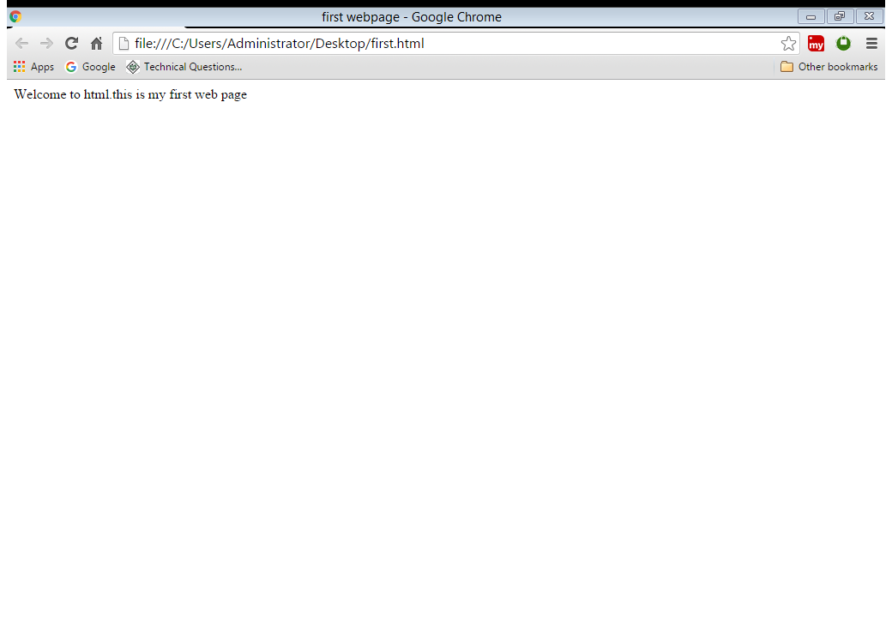

**Body Tag:**

This tag is used to represent the body part in the web page. And by using this tag we can place the contents in the webpage.

**Attributes of the body tag:**

1. **Align:**

It is used to specify the alignment of the content placed in the web page.

**Example:**

Align=”left/right/center/justify”

1. **Bgcolor:**

This attribute is used to apply background color of the webpage.

**Example:**

Bgcolor=”colorname/colorvalue”

1. **Text:**

By using this attribute we can change the text color.

**Example:**

Text=”colorname/colorvalue”

**Note:**

In HTML we can give the color values in two values

1. By using color names
2. By using color values

Again color values are two types

1. **6 digit hexa-decimal format**

**Syn:** #rrggbb

**Eg:** #3cf35c

1. **3 digit hexa decimal format**

**Syn:** #rgb

**Eg:** #e5f

1. **Title:**

This attribute is used to provide extra information about the webpage to the users.

**Example:**

Title= “any information”

1. **Left margin, top margin:**

By using these attributes we can sets the margin for the webpages.

**Example:**

Left margin=”number of pixels, inches, percentage, etc.”

Top margin=”number of pixels, inches, percentage, etc.”

1. **Background:**

This is used to apply background image for web page.

**Example:**

Background=”location of the image”.

**Note:**

Whenever we applying the background image we need not apply the background color.

**Example:**

**Program:**

<! Doctype html>

<html>

<head>

<title>my first web page</title>

</head>

<body align="justify" bgcolor="#ffffff" text="hai" leftmargin="20" top margin="50" background="E:\images1\images (12).jpg">

hcvdvkkv

jlmvlkdmfkms

</body>

</html>

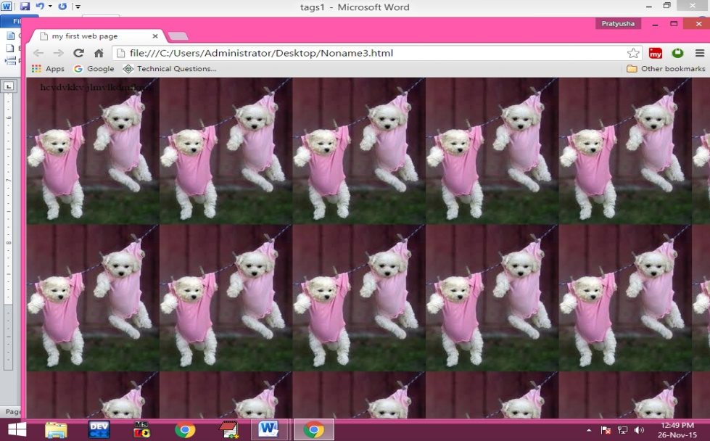**Output:**

**Background:**

This attribute is used to set the background image for webpage.

Background=”path of the image”

Here path are two types

1. Absolute path
2. Relative path
3. **Absolute path:**

In this type of path we can give the location of the file from the starting position of the drive.

Eg: E:\2015\aug\html\one.jpg

1. **Relative path:**

In relative path we can give location of the file from our current location.

Eg: images\one.jpg

**Example for Absolute path:**

<!Doctype html>

<html>

<head>

<title>

HTML Tags

</title>

</head>

<body bgcolor="red" text="ffffff" background="E:\images\sirisha\2015\my-images\1.jpg">

Discussing the body i.e texual data

</body>

</html>

**Example for Relative path:**

<!Doctype html>

<html>

<head>

<title>

HTML Tags

</title>

</head>

<body bgcolor="red" text="ffffff" background="images\1.jpg">

Discussing the body i.e texual data

</body>

</html>

**Font tag:**

By using this tag we can customize the styles of the font for specified text in the web page.

**Attributes of the font tag:**

1. **Color:**

By using this attributes we can specify the text color.

**Syntax:**

Color=”colorname/color value”

1. **Size:**

This is used to change the size of the font size from “1 to7” [here default size is 3]

**Syntax:**

Size=”1/2/3/4/5/6/7”

1. **Face:**

By using this attribute we can specify the font family face.

**Syntax:**

Face=”any font family”

**Example:**

**Program:**

<html>

<head>

<title>Font tag</title>

</head>

<body text=”red”>

Font tag is used to change the styles. <font size=”5”> Font tag is used to change the styles. </font><font color=”blue” size=”3” face=” Times New Roman”>Font tag is used to change the styles. </font><font color=”green”>Font tag is used to change</font> the styles.

</body>

<html>

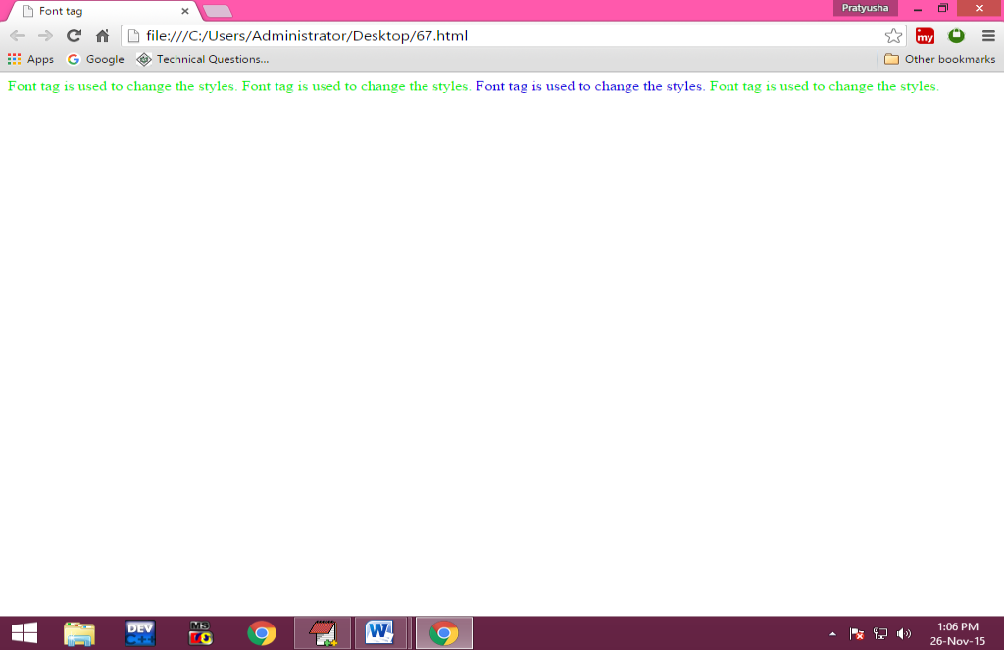**Output:**

**P tag: (paragraph tag)**

This tag is used to display the contents in the form of paragraphs.

**Attributes of the P tag:**

1. **Align:**

This attribute is used to align the contents inside the paragraphs.

Align= “left/right/center/justify”

**Note:**

If you want to provide the space to starting of the paragraph we use text-indent property in style attribute.

**Example:**

**Program:**

<html>

<head>

<title>Paragraphs</title>

</head>

<body>

<p align="right"><font color="dark pink">Paragraph in HTML</font></p><p align="left" style="color: red">in HTML Paragraphs</p><p align="center" style="text-indent: 50; color: green; background-color: dark green">Paragraph in html. Paragraph in html. Paragraph in html. Paragraph in html. Paragraph in html. Paragraph in html. Paragraph in html. Paragraph in html. Paragraph in html. Paragraph in html. Paragraph in html. Paragraph in html. Paragraph in html. Paragraph in html. Paragraph in html. Paragraph in html. Paragraph in html. Paragraph in html. Paragraph in html. Paragraph in html. Paragraph in html. Paragraph in html. Paragraph in html. Paragraph in html. Paragraph in html. Paragraph in html. Paragraph in html</p>

</body>

</html>

**Output:**

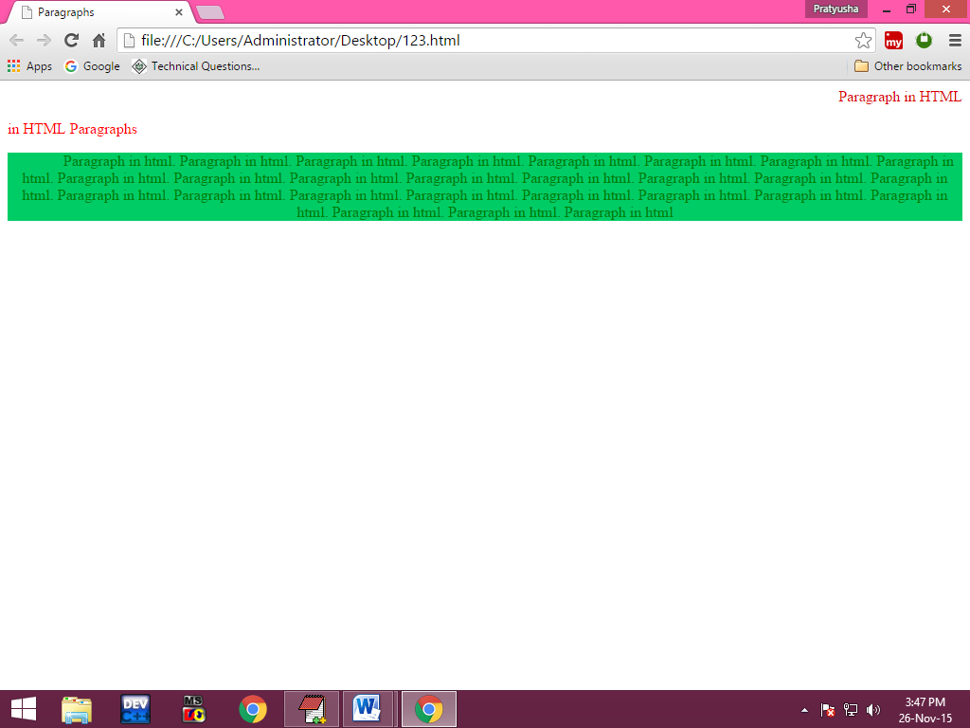

**Heading Tags:**

By using these tags we can place the headings in the webpage. In html there are six types of heading tags are available. These are h1, h2, h3, h4, h5, h6 and in those headers h1 is the largest heading and h6 is the smallest heading.

**Attributes of the header tags:**

**Align:**

**Syntax:**

Align=”left/right/center/justify”

**Example:**

**Program:**

<html>

<head>

<title> header tags</title>

</head>

<body>

<h1> welcome to BDPS </h1>

<h2> welcome to BDPS </h2>

<h3> welcome to BDPS </h3>

<h4> welcome to BDPS </h4>

<h5> welcome to BDPS </h5>

<h6> welcome to BDPS </h6>

</body>

</html>

**Output:**

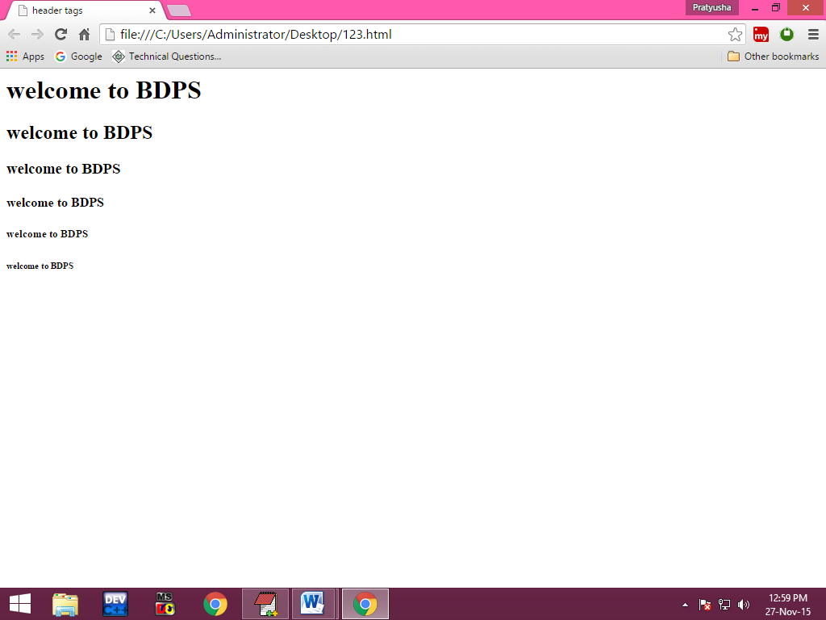

**Program:**

**<**html>

<head>

<title>Heading</title>

</head>

<body>

<h1 align="center" style="color:red">BDPS</h1>

<h2 align="center" style="color:blue">CMTES</h2>

<h3 align="center" style="color:green">APPLE</h3>

<h4 align="center" style="color:orange">INFOPARK</h4>

<h5 align="center" style="color:pink">VISION </h5>

<h6 align="center" style="color:purple">NIIT</h6>

</body>

<html>

Output:

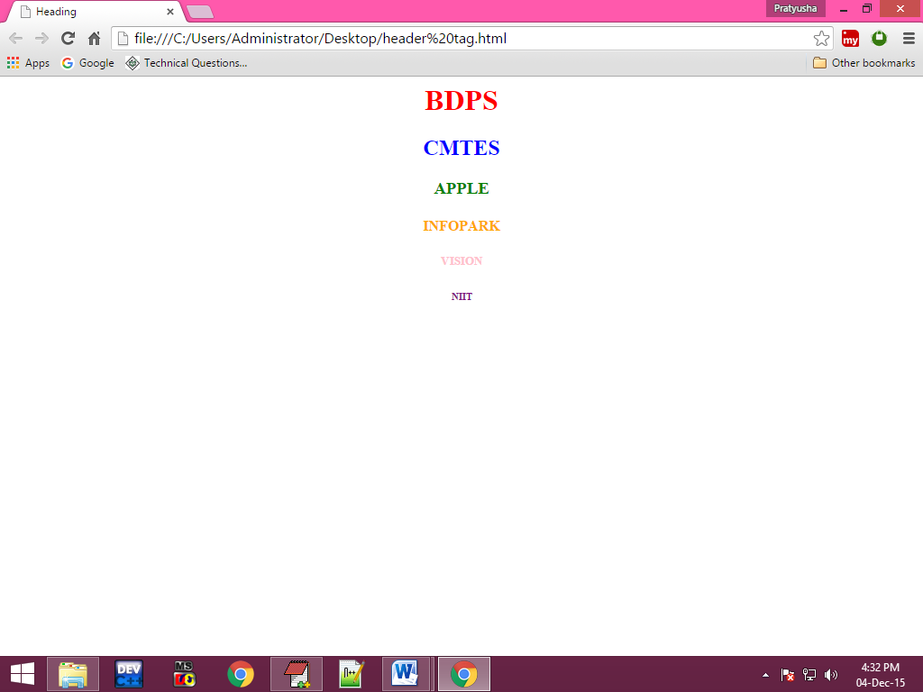

**Program:**

<html>

<head>

<title>header tags</title>

</head>

<body>

<h1 align=”center” style=”color:red; font-family: gabriola;text-shadow:5px 5px 5px black”>BDPS computer education</h1>

You can assign keyboard shortcuts (or shortcut keys) to a command, macro, font, style, or commonly used symbol.

</body>

</html>

**Output:**

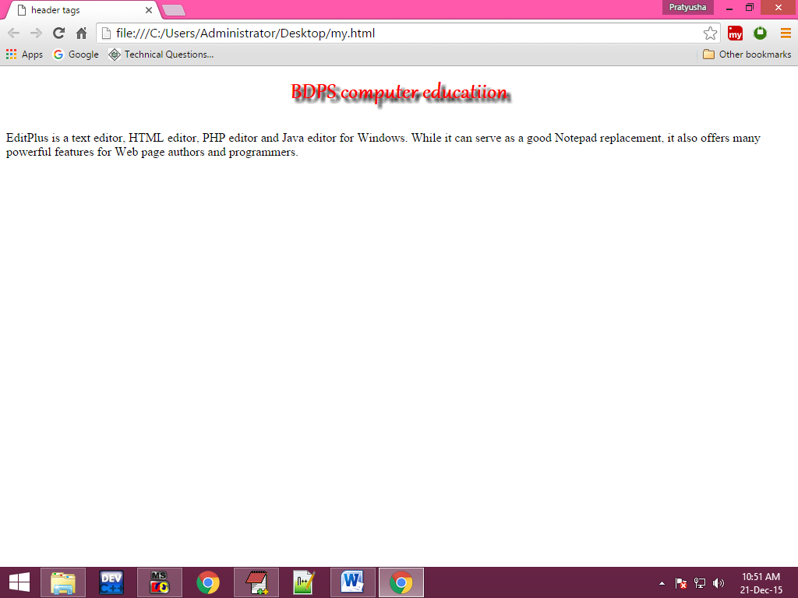

**Br tag:**

This tag is used to break the line and moves the curser to next line.br tag is a single tag.

**Center tag:**

Center tag is used to display the contents in center.

**Pre Tag:**

This tag is used to display the contents in the web page as it is we are written in html document. And whenever we are using pre tag it displays the contents in teletype or type writing format.

**Example:**

**Program**:

<html>

<head>

<title>br tag</title>

</head>

<body>

Editplus is a <br/>

Texteditor

<center>pratyusha</center>

<pre><font face=”times new roman”> editplus is a

Text

Editor</font></pre>

<pre>

Sno sname marks

1 sap 89

2 pratyu 78

</pre>

</body>

</html>

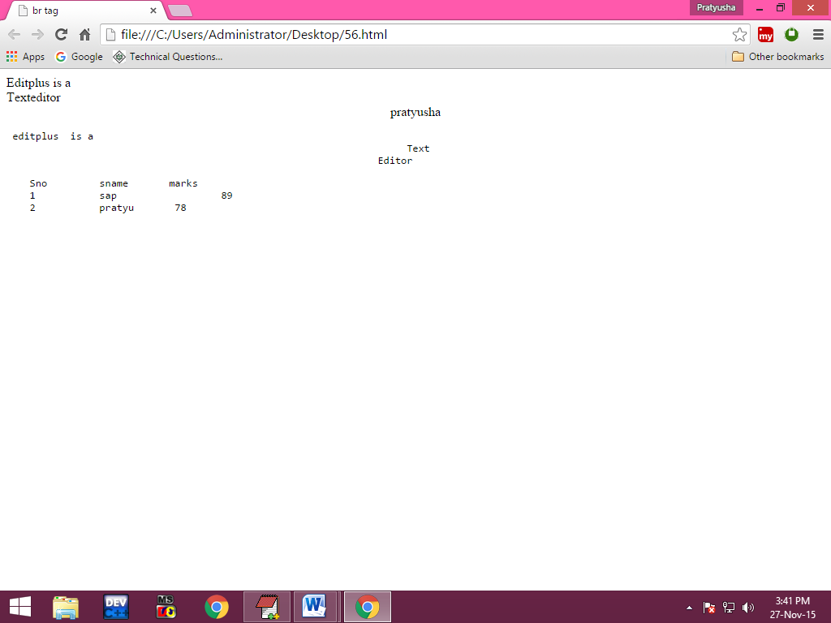**Output:**

**Hr tag:**

Hr tag stands for horizontal ruler and it is used to draw horizontal line on the webpage.

**Attributes of the hr tag:**

1. **Color:**

By using this attribute we can specify color of the horizontal line.

**Syntax:**

Color=”colorname/colorvalue”

1. **Size:**

This attribute is specify the thickness of the line.

**Syntax:**

Size=”number of pixels”

1. **Width:**

This is used to specify width.

**Syntax:**

Width=”number of pixels”

1. **Align:**

**Syntax:**

Align=”center/left/right”

**Example:**

**Program:**

<html>

<head>

<title> hr tag</title>

</head>

<body>

header part

<hr color="blue" size="5" width="500" align="left"/>

Contents part

<hr/>

Footer part

</body>

</html>

**Output:**

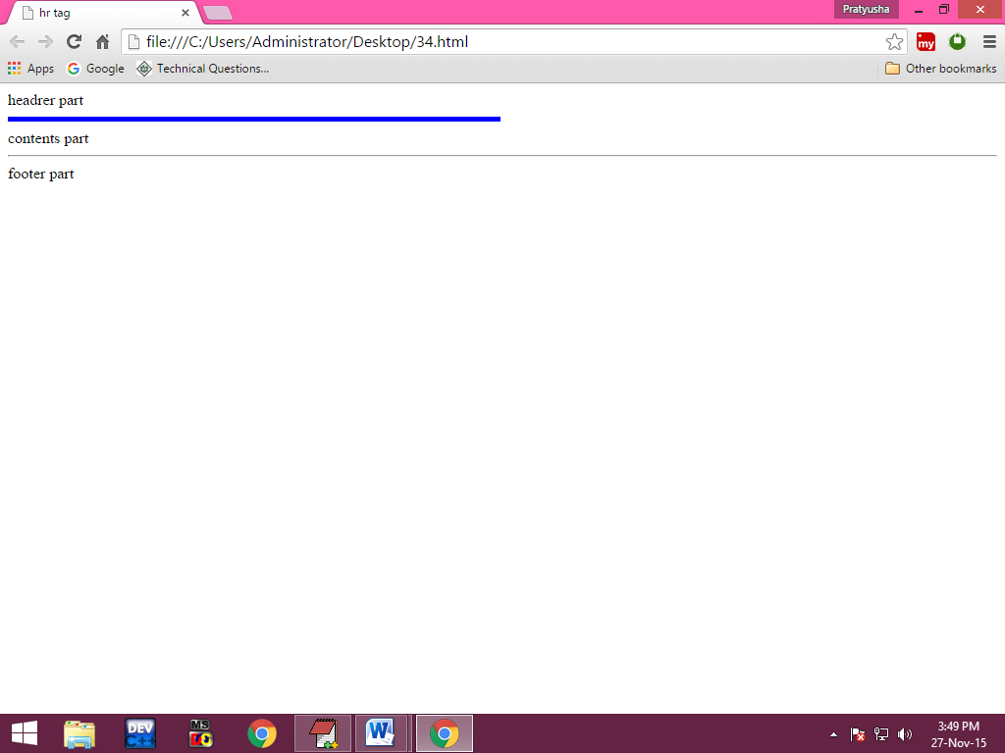

**Formatting tags:**

These are used to display the contents in the webpage in specified format. In HTML there are so many types of formatting tags are available some of them they are:

1. **<b>,<strong> tags**:

These tags are used to display the text in bold.

1. **<i>,<em>,<address>,<dfn>:**

These tags are used to display the text in italics

1. **<s>,<strike>,<del>:**

These tags are used to strike out the text.

1. **<u>, <ins>:**

These tags are used to insert underline for specified text

1. **<sup>:**

This tag is used to display the text in superscript.

1. **<sub>:**

This tag is used to display the text in subscript.

1. **<small>,<big>:**

These tags are used to increase or decrease the font size by 2 pixels

1. **<mark>tag:**

This tag is used to highlighting the specified content.

1. **Blink**:

This tag is used to blink the words. It works only in Firefox, it doesn’t work in google chrome.

1. **BDO:**

Bidirectional order

Dir=”rtl/ltr”

1. **Abbr, acronym:**

These tags are used to place abbreviation in the webpage.

**Example:**

**Program:**

<html>

<head>

<title> formatting tags</title>

</head>

<body>

A<sup>2</sup>+b<sup>2</sup>

Log<sub>10</sub>a

<details>

<summary>html tags </summary>

<details>

<summary>html</summary>

<li>head</li>

<li>body</li>

</details>

</details>

<bdo dir=”rtl”>HTML</bdo>

<br/>

#include

<code>

#include

</code>

<samp>  
output:100

</samp>  
<article>

This is my article

</article>

</body>

</html>

**Output:**

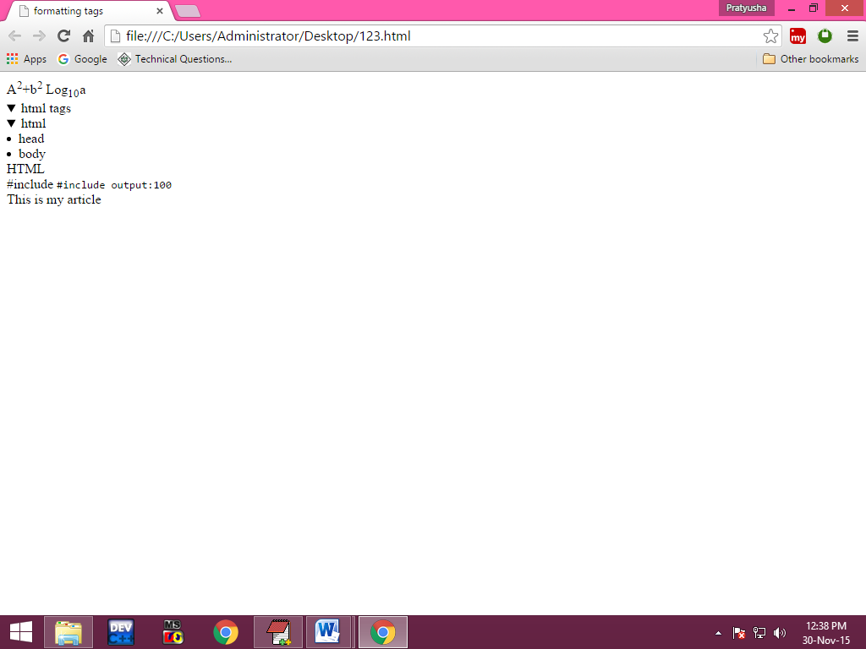

**Example:**

<html>

<head>

<title>HTML Elements</title>

</head>

<body>

<details>

<summary>Computer</summary>

<ul style="list-style-type:none">

<li>

<details>

<summary>Local Disk(C)</summary>

</details>

</li>

<li>

<details>

<summary>Local Disk(D)</summary>

</details>

</li>

</ul>

</details>

</body>

</html>

**Output:**

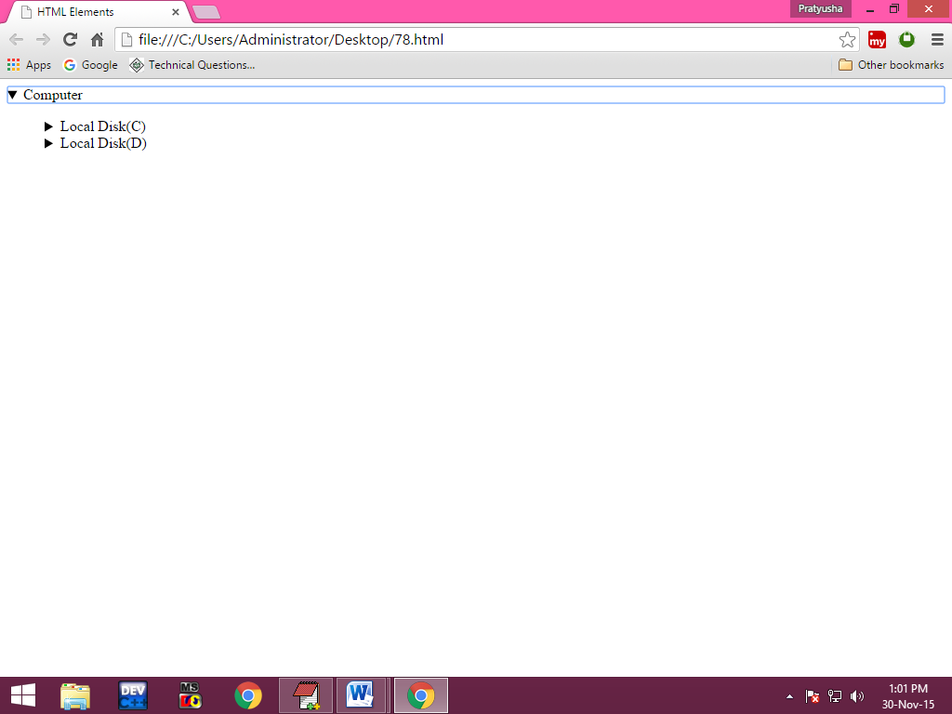

**Image tag:**

This tag is used to displays the images in web page. We can place any format of the images like jpg, png, gif etc..

**Attributes of the img tag:**

1. **Src:**

This attribute is used to specify the location of the image.

**Syntax:**

Src=”path of the image”(location of the image)

1. **Border:**

By using this attribute we can specify the thickness of the border.

**Syntax:**

Border=”number of pixels”

1. **Height, Width:**

These attributes are used to specify height and width of the image.

**Syntax:**

Height=”number of pixels”

Width=”number of pixels”

1. **Align:**

**Syntax:**

Align=”left/right”

1. **hspace, vspace:**

These attributes are used to specify the position of the image

**Syntax:**

Hspace=”number of pixels”

Vspace=”number of pixels”

1. **Alt:**

This attribute is used to write alternative message for the images. And it is displayed when the image is not available.

**Syntax:**

alt=”any information”

**Example:**

**Program:**

<html>

<head>

<title>images</title>

</head>

<body>

<img src="E:\pratyu new\20150122_154842.jpg" height="150" width="200" border="4" align="leftt" hspace="200" vspace="100" style="border-left-color:red"/>

</body>

</html>

**Example:**

**Program:**

<html>

<head>

<title>images</title>

</head>

<body background="images\3.jpg">

<img src="images\4.jpg" height="150" width="200" border="4" align="right" hspace="200" vspace="200" style="border-left-color:red; border-right-color:blue;border-bottom-style:double "/>

</body>

</html>

**Marquee Tag:**

This tag is used in scrolling the contents inside webpage.

**Attributes of the marquee tag:**

1. **Direction:**

By using this attribute we can specify in which direction contents will be scrolling.

**Syntax:**

Direction=”left/right/up/down”

1. **Bgcolor:**

This attribute is used to specify the background color of the marquee tag.

**Syntax:**

Bgcolor=”colorname/colorvalue”

1. **Height, width:**

**Syntax:**

Height=“number of pixels”

Width=”number of pixels”

1. **Scroll amount:**

This attribute is used to specify how many number of pixels will be scrolled at a time.

**Syntax:**

Scrollamount=”number of pixels”

1. **Scrolldelay:**

By using this attribute we can specify how much time scrolling content will be wait.

**Syntax:**

Scrolldelay=”number of milliseconds”

1. **Behavior:**

This attribute is used to specify the behavior of the scrolling contents.

**Syntax:**

Behavior=”slide/motion/alternate”

1. **Loop:**

By using this attribute we can specify how many times scrolling content will be scrolled.

**Syntax:**

Loop=”number of times”

**Example:**

**Program:**

<html>

<head>

<title> marquee tag </title>

</head>

<body>

<center>

<marquee bgcolor="blue" direction="right" width="300" height="500" scrollamount="50" scrolldelay="500" behavior="alternate" loop="4">

<img src="E:\images1\images (7).jpg" height="30" width="40">

scrolling the text

</marquee>

</center>

</body>

</html>

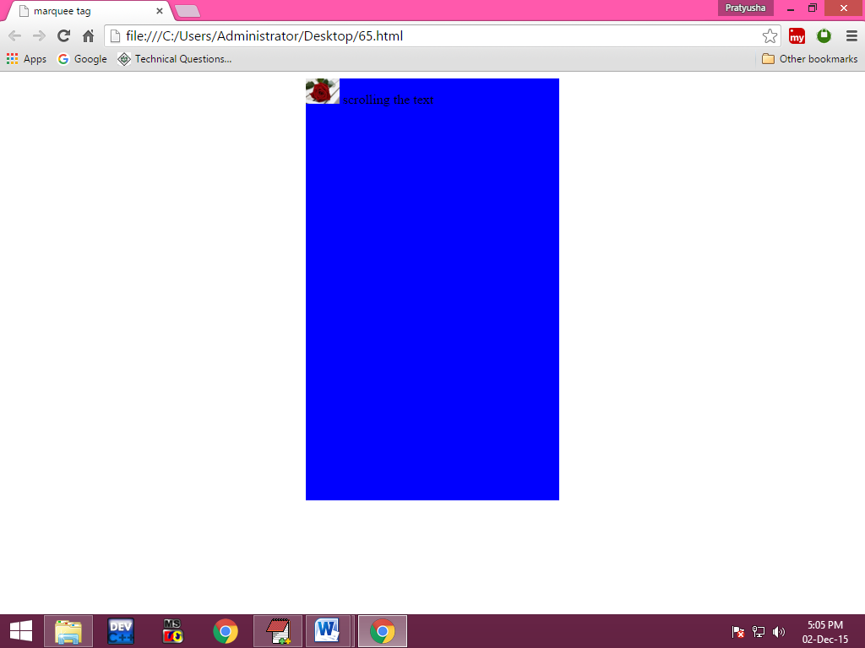**Output:**

**Example1:**

<html>

<head>

<title>marquee tag1</title>

</head>

<body>

<img src="E:\images1\download.jpg" height="500" width="500">

<p style="height:50">

</p>

<marquee bgcolor="blue" style="color:red" scrollamount="50" direction="right">

local news

</marquee>

<marquee bgcolor="yellow" style="color:black" scrollamount="50" direction="right">

national news

</marquee>

</body>

</html>  
Output:

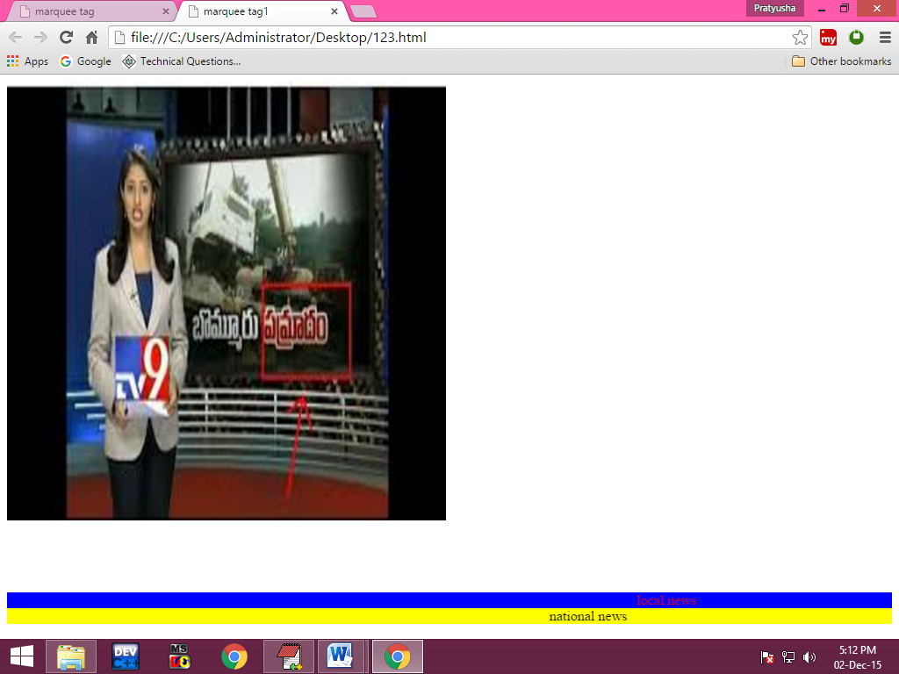

**HTML Links:**

**Hyper Links:**

Hyperlinks are nothing but a hypertext which is used to perform a particular task like navigating form one webpage to another webpage or transferring the data from one webpage to the users.

In html there are four types of hyperlinks are available. Those are

1. Hyperlinks

2. Web links

3. Email links

4. Download link

**1. Hyper Link:**

These are used to navigate from one webpage to another webpage in the same websites.

1. **Web Link:**

These links are used to navigate from one web page to another website.

1. **Email Links:**

These types of links are used to transfer the data from one webpage to users of the same website or different websites.

1. **Download Links**:

These links gives information to the users

To create any type of links in HTML we use a tag <a> (anchor) tag.

**Attribute of the hyperlinks:**

1. **Href(hyperlinks reference):**

This attribute is used to specify the destination file location.

**Syntax:**

href=”path of the file”

1. **Name:**

This attribute is used to give the name for the hyperlinks.

**Syntax:**

Name=”any name”

1. **Title:**

This attribute is used to give extra information to the user.

**Syntax:**

Title=”any text”

1. **Target:**

This attribute is used to specify where the destination file will be opened.

**Syntax:**

Target=”_self/_blank/_new/_window/_win/framenames”

**Forbidden attributes:**

When attribute name is equal to attribute value, then those attributes are known as Forbidden attributes. Below are the examples.

Download=”download”

Noresize=”noresize”

Disabled=”disabled”

**Empty anchors:**

In empty we do not provides destination file location.

**Eg:**

<a href=”#”>Click here</a>

**Named anchors:**

If you provide names for the hyperlinks that hyperlinks are called as named anchors.

**Eg:**

<a href=”pre.html” name=”first”>

Click here</a>

**Example:**

**Program:**

<html>

<head>

<title>hyperlinks</title>

</head>

<body>

<a href="images1" target="_blank" name="page" title="click here to go for that page">click here</a>

<br/>

<a href="http:\\www.onlinesbi.com" target="_blank">gotosbi</a>

<br/>

<a href="mailto:bdps.123@gmail.com? sub: password&body:your password is 1234">send email</a><br/>

<br/>

<a href="A.JPG" download="download">click here to download</a>

<br/>

<a href="E:\images1\images.jpg" download="download"><img src="E:\images\images2\1.jpg" height="200" width="200"></a>

</a>

<a href="C:\Users\Public\Music\Sample Music\Kalimba.mp3"download="download">song.mp3</a>

</body>

</html>

**Output:**

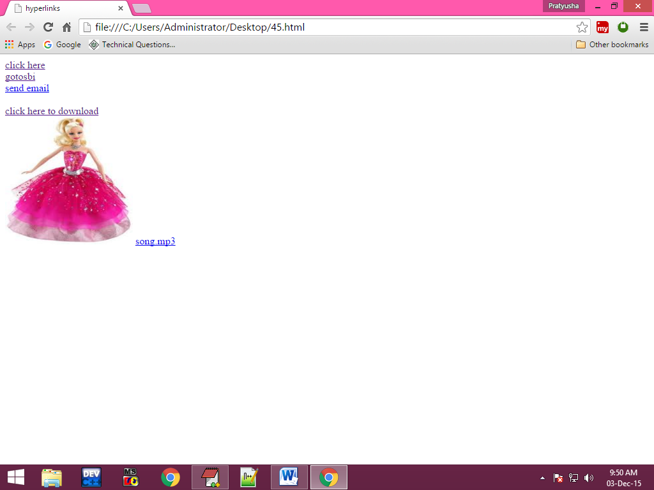

**Example 1:**

<html>

<head>

<title>hyperlinks</title>

</head>

<body>

<p id="top">EditPlus is a text editor, HTML editor, PHP editor and Java editor for Windows. While it can serve as a good Notepad replacement, it also offers many powerful features for Web page authors and programmers.

EditPlus is a text editor, HTML editor, PHP editor and Java editor for Windows. While it can serve as a good Notepad replacement, it also offers many powerful features for Web page authors and programmers.

</p>

<a href="#i">nextlink</a>

<br/>

<br/>

<br/>

<br/>

<br/>

<br/>

<br/>

<p id="i">this is my paragraph</p>

<a href="#top">click here</a>

</body>

</html>

**Output:**

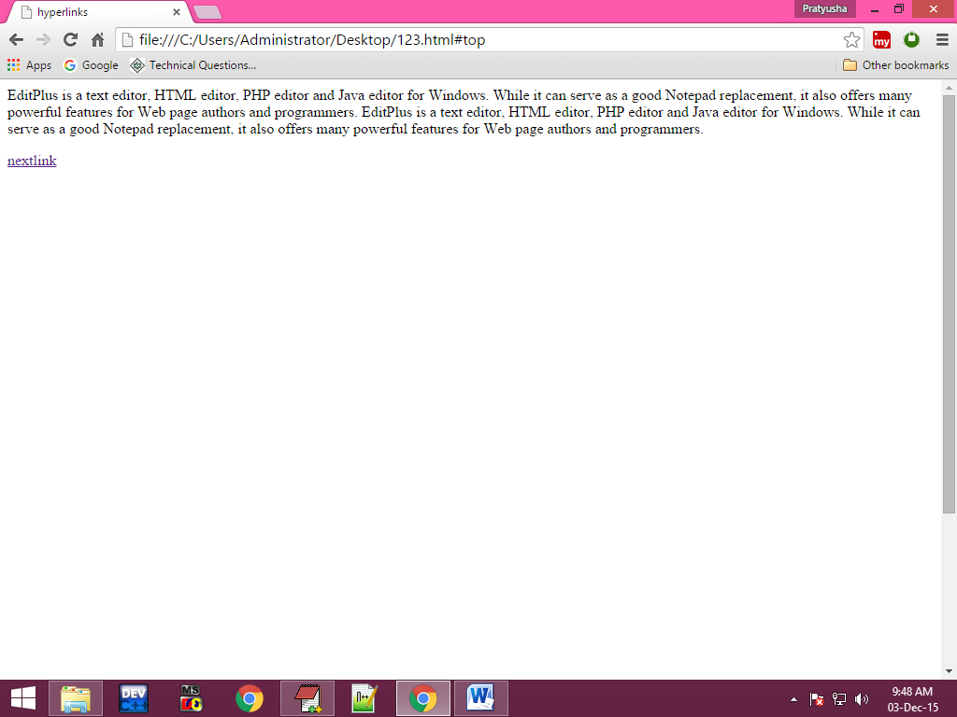

**Lists:**

If you want to place the contents in list format we use following three in list format we use following three type lists.

1. Ordered List
2. Unordered List
3. Definition List (or) Description List

**1. Ordered List:**

Whenever we are using ordered list it can display numbers before the contents of the list. To create ordered list we use a tag <ol> and to place list items in ordered list we use a tag <li>.

**Attributes of <ol> tag:**

1. **Type:**

This attribute is used to specify order type.

**Syntax:**

Type=”any number/a/A/i/I

1. **Start:**

This attribute is used to specify from which number list will be started.

**Syntax:**

start=”any number”

**2. Unordered List:**

Whenever we are using unordered list it can display the symbols before the contents of list items. To create unordered list we use a tag <ul> and to place list items in unordered list we use a tag <li>.

**Attributes of <ul> tag:**

1. **Type:**

This attribute is used to specify type.

**Syntax:**

Type=”disk/circle/square/none”

**3. Definition list/description list:**

Whenever we are using definition list it can place all the definitions in list format. To create definition list/description list we use a tag <dl> and to place definition types/description type in definition list we use a tag <dt> and to definition data/description data in definition list we use a tag <dd>.

**Example:**

**Program:**

<html>

<head>

<title>lists</title>

</head>

<body>

<ol start="1" type="a">

<li><a href="#">unit-1</a></li>

<li>unit-2</li>

<li>unit-3</li>

<li>unit-4</li>

<li>unit-5</li>

</ol>

<ul type="square">

<li>chapter-1</li>

<li>chapter-2</li>

<li>chapter-3</li>

<li>chapter-4</li>

</ul>

<dl>

<dt>HTML

<dd> It is a markup language</dd>

</dt>

<dt>c language

<dd> c is a programming language</dd>

</dt>

<dt> java

<dd> java is an object oriented programming language</dd>

</dt>

</dl>

</body>

</html>

**Output:**

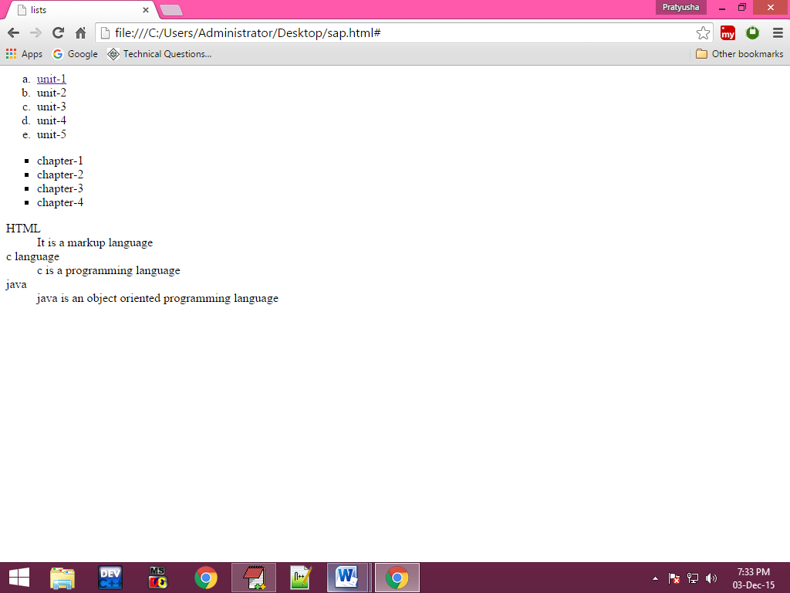

**Example 1:**

<html>

<head>

<title>List2</title>

</head>

<body>

<ol type="1" start="1">

<details>

<summary><a href="#">Unit-1</a></summary>

<ul type="square">

<li>Chapter-1</li>

<li>Chapter-2</li>

<li>Chapter-3</li>

<li>Chapter-4</li>

</ul>

</details>

<details>

<summary><a href="#">Unit-2</a></summary>

<ul type="disk">

<li>Chapter-1</li>

<li>Chapter-2</li>

<li>Chapter-3</li>

<li>Chapter-4</li>

</ul>

</details>

<li><a href="#">Unit-1</a></li>

<li><a href="#">Unit-2</a></li>

</ol>

</body>

</html>

Output: 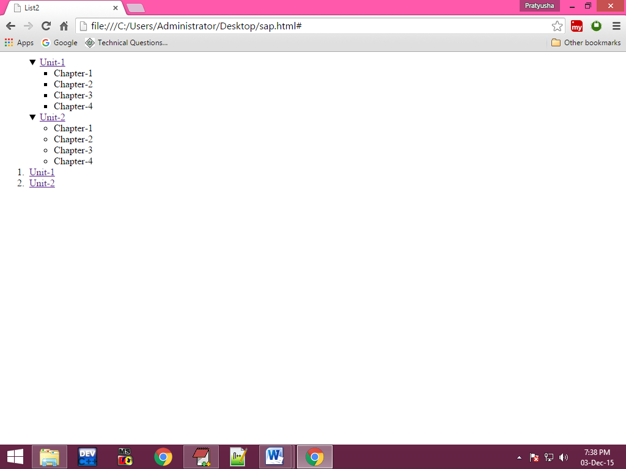

**Frames:**

Frames concept is used to display the multiple documents in the same webpage at the same time

(or)

Divide the webpage into multiple parts.

To work with frames concept, we us tag frameset.

**Frameset:**

This tag is used to divide the webpage into either horizontally or vertically.

**Attributes:**

1. **Rows:**

By using this attribute we can divide the webpage horizontally.

**Syntax:**

Rows=”sizes of the every part”

1. **Cols:**

By using this we can divide the webpage vertically.

**Syntax:**

Cols=”sizes of the every part”

1. **Border:**

It is used to specify size of the frame.

**Syntax:**

Border=”number of pixels”

1. **Border color:**

This attribute specifies the border color of the frames.

**Syntax:**

Bordercolor=”colorname/colorvalue”

**Frame:**

This tag used to display the particular documents in particular division.

**Attributes:**

1. **Src:**

By using this attribute we can specify the path of the file.

**Syntax:**

Src=”location of the file”

1. **Scrolling:**

**Syntax:**

Scrolling=”auto/yes/no”

1. **Noresize:**

**Syntax**:

Noresize=”noresize”

1. **Name:**

This attribute is used to identify frames easily.

**Syntax:**

Name=”any name”

**Example:**

**Program:**

<html>

<head>

<title>frames</title>

</head>

<frameset rows="20%,70%,20%" border="5" bordercolor="red">

<frame src="heading.html" name="header"/>

<frame src="123.txt" scrolling="no" noresize="noresize" name="contents"/>

<frame src="footer.html" name="footer"/>

</frameset>

</html>

**For heading.html:**

<h1 align="center" text="red">BDPS computer education</h1>

**For footer.html:**

<h2 align="center"> contact for any details</h2>

**For contents:**

We have to take any text file with data.

**Output:**

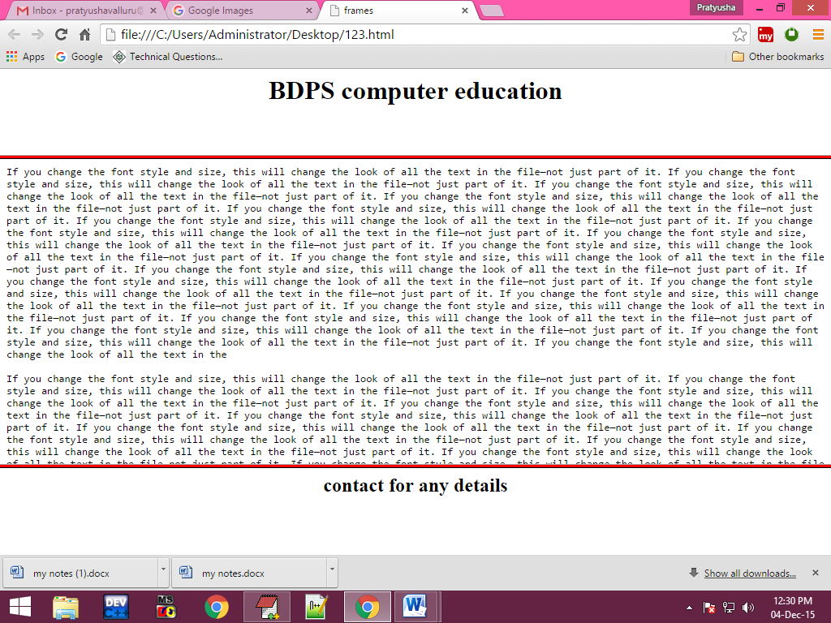

**Iframes:**

Iframes stands for inner frames.by using this iframe we can divide the one part of the web page.

**Attributes of iframe:**

1. **height:**

**Syntax:**

Height=”number of pixels”

1. **Width:**

**Syntax:**

Width=”number of pixels”

1. **Marginwidth:**

**Syntax:**

Marginwidth=”number of pixels”

1. **Marginheight:**

**Syntax:**

Marginheight=”number of pixels”

1. **Src:**

**Syntax:** src=”source of file location”

1. **Scrolling:**

**Syntax:**

Scrolling=”auto/yes/no”

**Example:**

**Program:**

<html>

<head>

<title>iframes</title>

</head>

<body>

<iframe height="200" width="200" style="position:absolute;right:30;top:200" src="sap.txt" scrolling="yes" marginwidth="30" marginheight="20">

</iframe>

</body>

</html>

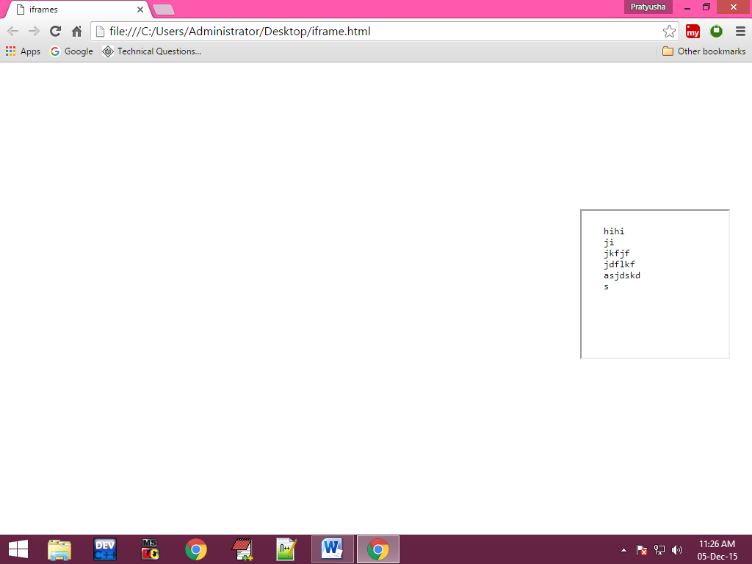**Output:**

**Audio/video tags:**

This tag is used for paly the audio and videos on the web page.

**video tags**

**<video>**

**Attributes:**

1. **Src**
2. **Controls**
3. **Height**
4. **Width**
5. **Loop**
6. **Autoplay**

**Audio tags**

**<audio>**

**Attributes:**

1. **Src**
2. **Controls**
3. **Loop**
4. **Autoplay**

**Example:**

<html>

<head>

<title> media files</title>

</head>

<body>

<video src="E:\my phone data\watsup video\VID-20151013-WA0001.mp4" controls="controls" height="500" width=700" loop="3" autoplay="autoplay" >

</video>

<audio src="E:\my phone data\watsup audio\AUD-20151004-WA0000.mp3" controls="controls" loop="3" autoplay="autoplay"></audio>

</body>

</html>

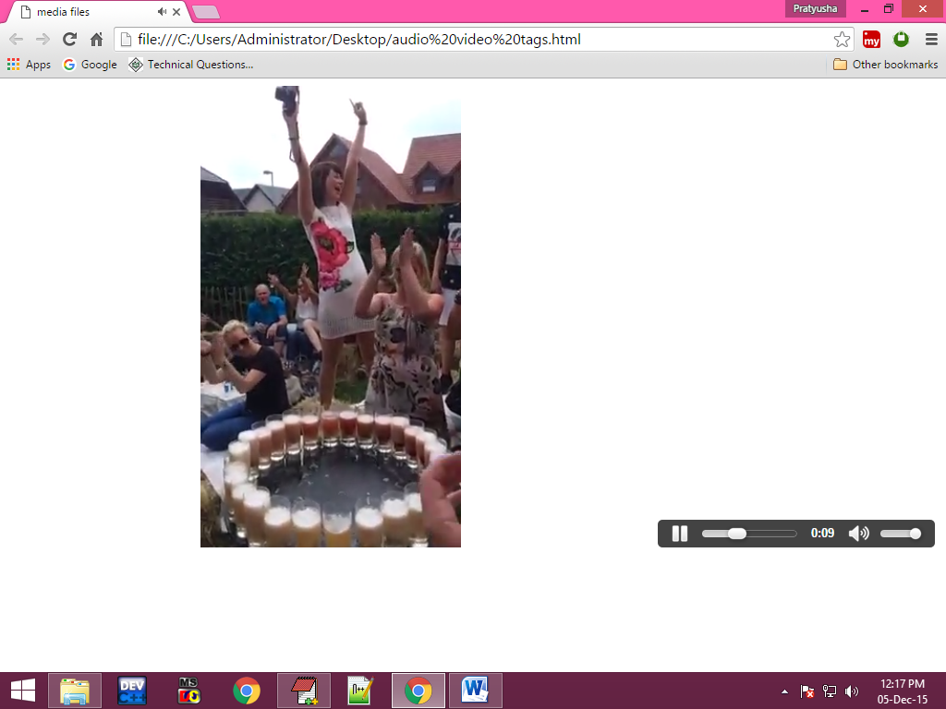**Output:**

**Table Tag:**

This tag is used to place the tables in the web space and divides the webpage in to number of parts. To represent rows in tables we use a tag tr. And to represent columns we use the tags td, th.

**Subtags of the table tag:**

1. Tr (tab row)
2. Td (tab data)
3. Th (tab header)
4. Caption

**Attributes of the table tag:**

1. **Border:**

This is used to specify thickness of the border.

**Syntax:**

Border=”number of pixels”

1. **Border Color:**

This is used to specify border color of the table.

**Syntax:**

Bordercolor=”colorname/colorvalue”

1. **Bgcolor:**

If we want to change background color of the table then we use bgcolor.

**Syntax:**

Bgcolor=”colorname/colorvalue”

1. **Background:**

This attribute is used to specify the background image for the table tag.

**Syntax:**

Background=”path of the file”;

1. **Align:**

By using this attribute we can specify the alignment of the table tag.

**Syntax:**

Align=”left/right/center”

1. **Height/width:**

These are used to specify the sizes of the table tag.

**Syntax:**

Height=”number of pixels”

Width=”number of pixels”

1. **Cellspacing:**

This attribute is used to specify space between the cells of the table.

**Syntax:**

Cellspacing=”number of pixel”;

1. **Cellpadding:**

This attribute is used to provide the space between contents of the cell and border of the cell.

**Syntax:**

Cellpadding=”number of pixels”

**Attributes of the tr tag:**

1. Bgcolor
2. Background
3. Height
4. Align
5. Valign

**Attributes of the td, th tag:**

1. Bgcolor
2. Background
3. Height, width
4. Align
5. Valign
6. **Colspan:**

Merging two or more cells in horizontally direction (in a same row) is called as colspan.

**Syntax:**

Colspan=”number of cells”

1. **Rowspan:**

Merging two or more cells in vertical direction (in different rows) is called as rowspan.

**Syntax:**

Rowspan=”number of cells”

1. **Caption tag:**

This tag is used to give the caption for the table.

**Attribute of Caption tag:**

1. **Align:**

**Syntax:**

Align=”top/bottom”

**Example :**

**Program:**

**Using colspan:**

<html>

<head>

<title>colspan</title>

</head>

<body>

<table border="2">

<tr>

<th></th>

<th>1</th>

<th>2</th>

<th>3</th>

</tr>

<tr>

<th>MON</th>

<td>dca</td>

<td colspan="2" align="center">c</td>

</tr>

<tr>

<th>TUE</th>

<td colspan="2" align="center">ds</td>

<td>cpp</td>

</tr>

<tr>

<th>WED</th>

<td colspan="3" align="center">java</td>

</tr>

</table>

</body>

</html>

**Output:**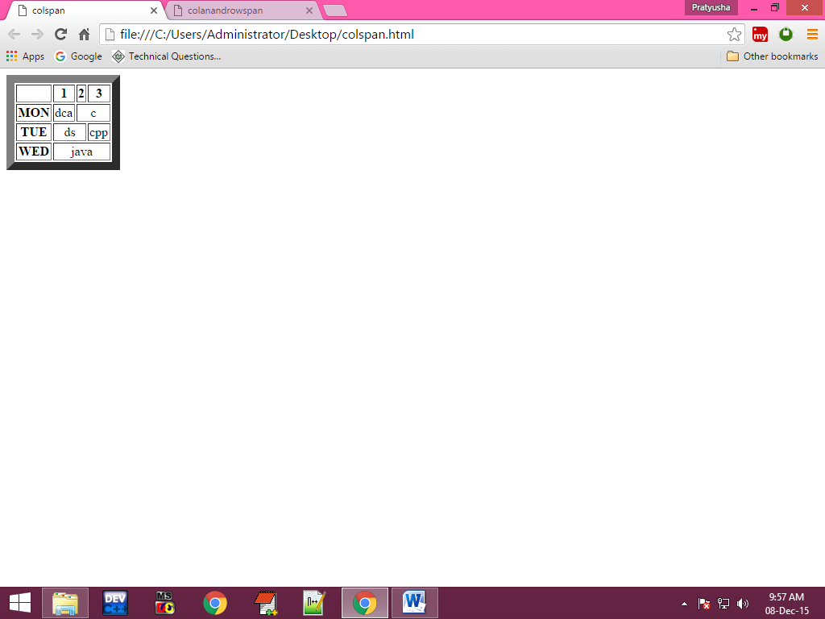

**Using colspan and Rowspan:**

**Program:**

<html>

<head>

<title>colanandrowspan</title>

</head>

<body>

<table border="2" height="100%" width="100%" align="center">

<tr>

<td>4</td>

<td colspan="2" align="center" rowspan="2">5</td>

</tr>

<tr>

<td>6</td>

</tr>

<thead>

<tr height="100">

<td>1</td>

<td>2</td>

<td>3</td>

</tr>

</thead>

</table>

</body>

</html>

**Output:**

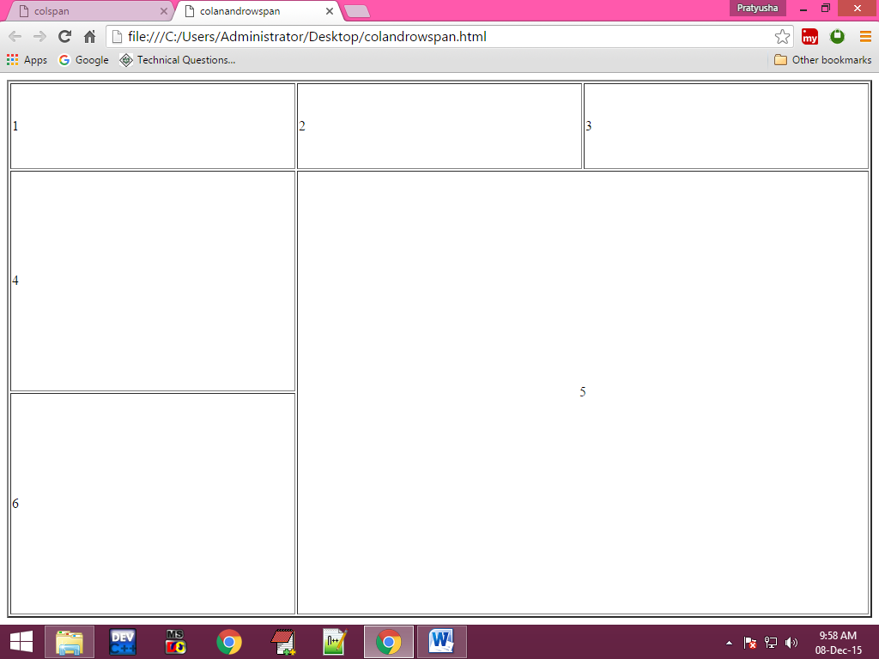

**Using Rowspan:**

<html>

<head>

<title>tables</title>

</head>

<body>

<table border="2">

<tr>

<th>Sno</th>

<th>Sname</th>

<th>marks</th>

</tr>

<tr>

<td>

<table>

<tr>

<td style="borderbottom:solid">101</td>

</tr>

<tr>

<td>102</td>

</tr>

</table>

</td>

<td>ravi</td>

<td>90</td>

</tr>

<tr>

<td>2</td>

<td>naveen</td>

<td>

<table>

<tr>

<td style="border-right:solid">40</td>

<td>40</td>

</tr>

</table>

</td>

</tr>

</table>

</body>

</html>

**Output:**

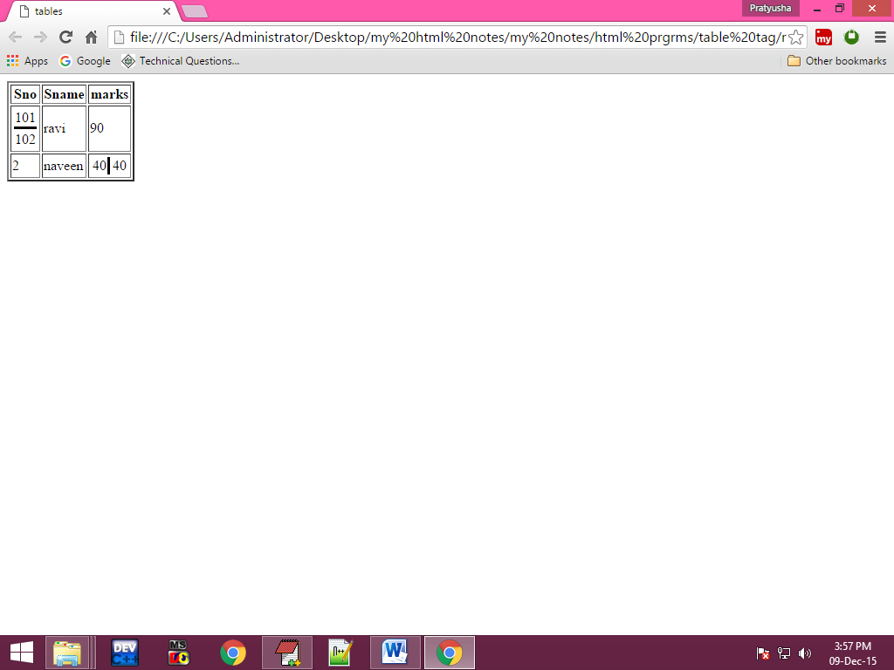

**Div:**

This tag is used to divide the webpage into number of parts. And div tag is acting as a container. In div tag we can place any type of contents like, text, images, tables, etc., And whenever we are using div tag it can take less amount of memory to compare frames &tables and it loads the webpage fast because div tag is light weight component. Whenever we are using div tag it can divide the webpage based on the contents here we no need to re specify size

**Attribute of div tag:**

1. **align**:

**Syntax:**

align=”left/right/center/justify”

<html>

<head>

<title>div tag</title>

</head>

<body>

<div style="border-bottom:solid" align="center">

div tag1

</div>

<div style="border-bottom:solid" align="center">

<img src="E:\images\images1\2.jpg" height="500">

</div>

<div align="center">

div tag3

</div>

</body>

</html>

**Output:**

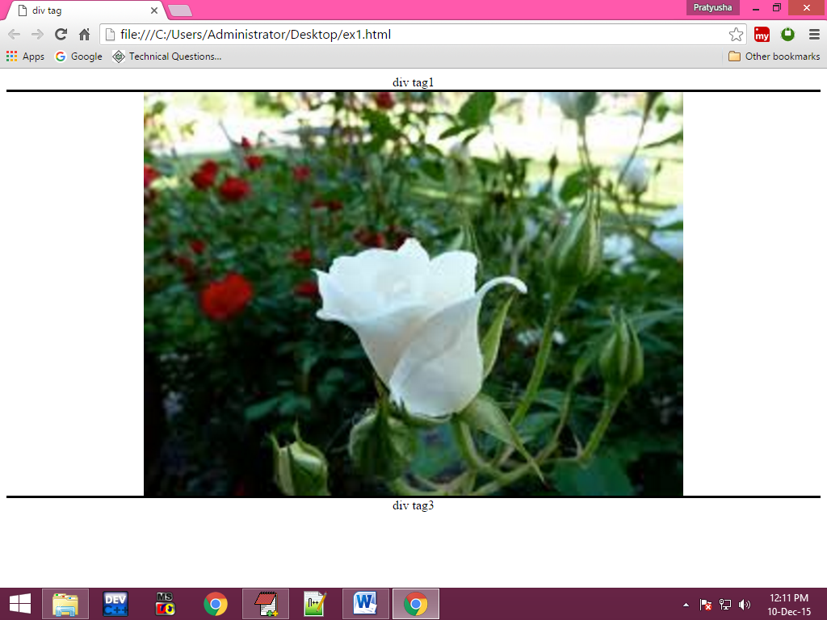

**Example 2:**

<html>

<head>

<title>div tags</title>

</head>

<body>

<div style="border-right:solid;height:100;width:100;">

editplus

editpluseditplus

editpluseditplus

editpluseditplus

editpluseditplus

editpluseditplus

editplus

</div>

<div style="height:100;width:40;border-right:solid;position:absolute;left:210;top=10">

editplus

editpluseditplus

editpluseditplus

editpluseditplus

editpluseditplus

editplus

</div>

<div style="height:100;width:40;border-right:solid;position:relative;left:610;bottom:620">

editplus

editpluseditplus

editpluseditplus

editplus

</div>

</body>

</html>

**Output:**

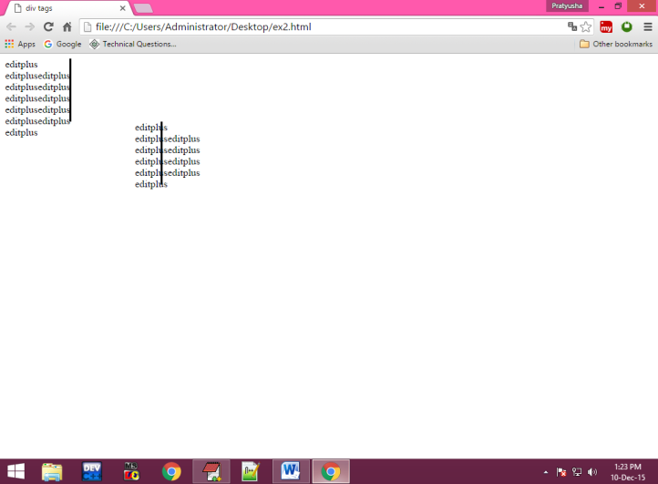

**Example 3:**

<html>

<head>

</head>

<body>

<div style="height:10;width:100;border:solid;line-height:18px;position:absolute;top:300;background-color:wheat;opacity:0.2;transform:rotate(330deg) align=center">

<h1>BDPS</h1>

</div>

<div>

welcome to bdps

</div>

</body>

</html>

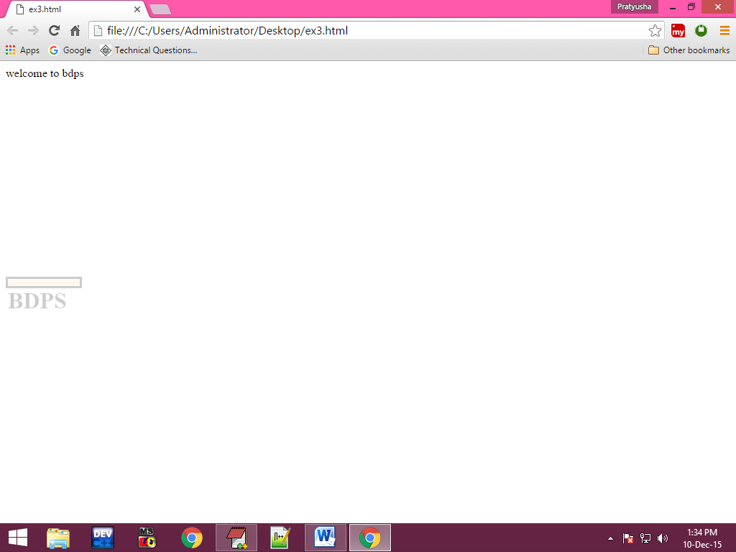**Output:**

**Example 4:**

<html>

<head>

<title> div tags</title>

</head>

<body>

<div style="height:400;width:300;border:solid;padding:15px">

<img src="E:\my html notes\my notes\html images\1.jpg" height="100" width="100" style="float:right"/>

EditPlus is a text editor, HTML editor, PHP editor and Java editor for Windows. While it can serve as a good Notepad replacement, it also offers many powerful features for Web page authors and programmers.

EditPlus is a text editor, HTML editor, PHP editor and Java editor for Windows. While it can serve as a good Notepad replacement, it also offers many powerful features for Web page authors and programmers.

EditPlus is a text editor, HTML editor, PHP editor and Java editor for Windows. While it can serve as a good Notepad replacement, it also offers many powerful features for Web page authors and programmers.

</div>

</body>

</html>

**Output:**

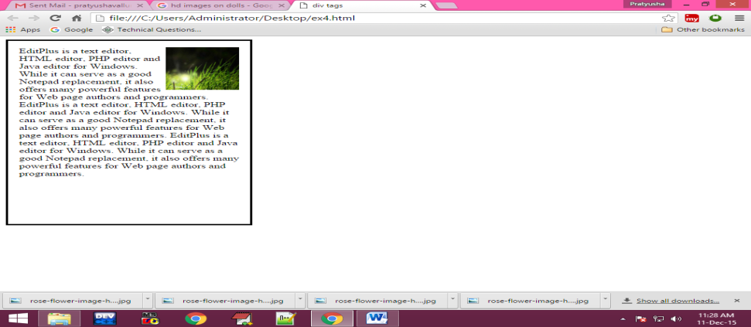

**Form Controls:**

If you want to read the data from the user in the webpages we use form controls. In html there are so many form controls are available some of them are

* text box
* password
* buttons
* radio button
* submit
* reset
* checkbox
* image
* file
* textarea or multiline text box
* dropdown list
* list box

If you want to create any type of form controls we use the following tags.

* Input
* label
* textarea
* select
* option
* optgroup

**Attributes of input tag:**

1) type

2) name

3) value

4) size

5) maxlength

6) autofocus

7) readonly

8) disabled

9) checked

10) multiple

11) src

12) height

13) width

**Attributes of the textarea:**

1) name

2) rows

3) cols

**Attributes of the select tag:**

1) name

2) multiple

**Subtags of the select tag:**

<option>

**Attributes of the option tag:**

1) value

2) selected

**Example:**

<html>

<head>

<title>registration form</title>

</head>

<body>

<form action="body.html" name="regform" method="post">

<label>name:</label>

<input type="text" value="bdps" name="t1" size="20" maxlength="5" autofocus="autofocus" readonly="readonly" disabled="disabled"/>

<br/>

<label>password</label>

<input type="password" value="abcd" name="p1" autofocus="autofocus"/>

<br/>

<label>gender</label>

<input type="radio" name="r1" value="male" checked="checked"/>male

<input type="radio" name="r1" value="female" checked="checked"/>female<br/>

hobbies:

<input type="checkbox" value="play" name="c1" checked="checked"/>playing

<input type="checkbox" value="write" name="c2" checked="checked"/>writing

<input type="checkbox" value="read" name="c3" checked="checked"/>reading

<br/>

address:

<textarea cols="5" rows="4" name="addr">vijayawada</textarea>

<br/>

date of joining:

<select name="day">

<option>----select---</option>

<option value="1">1</option>

<option value="2">2</option>

<option value="3">3</option>

<option value="4">4</option>

</select>dd

<select name="month">

<option>--select--</option>

<option value="1">1</option>

<option value="2">2</option>

<option value="3">3</option>

<option value="4" selected="selected">4</option>

</select>mm

<select name="year">

<option>--select---</option>

<option value="1">2011</option>

<option value="2">2012</option>

<option value="3">2013</option>

<option value="4">2014</option>

<option>others</option>

</select>yyyy

<br/>

upload photo:<input type="file"/>

<br/>

<input type="button" value="button"/>

<input type="submit" value="submit"/>

<input type="reset" value="reset"/>

</form>

</body>

</html>

**Output:**

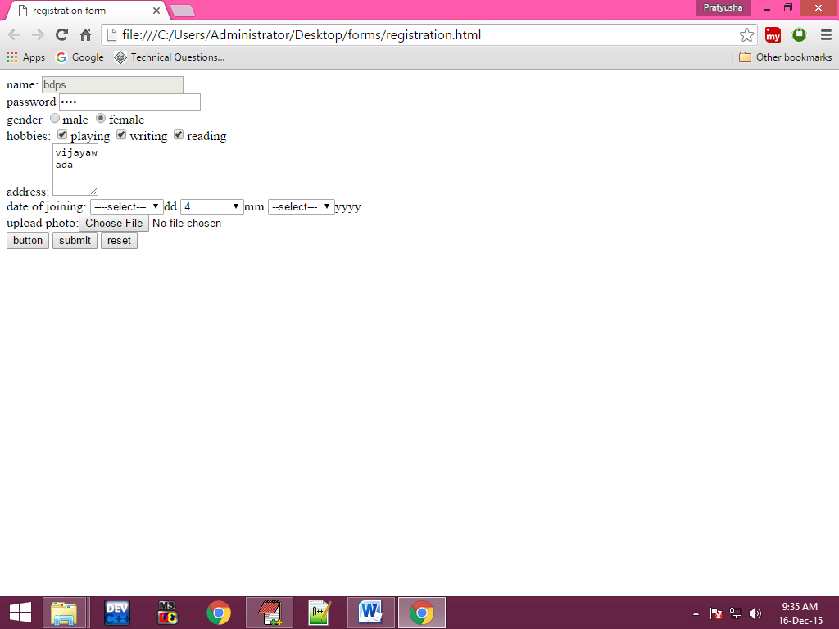

**Example:**

<html>

<head>

<title>login form</title>

</head>

<body>

<fieldset style="height:200;width:200;background-color:blue;position:absolute;right:30;top:200;border-top-left-radius:50px;border-bottom-right-radius:50px"/>

<legend align="right"><font size="5">login form</font></legend>

<table style="margin-top:40;">

<form action="one.php" name="login">

<tr>

<td>username:</td>

<td><input type="text" name="uname"/></td>

</tr>

<tr>

<td>password</td>

<td><input type="password" name="pwd"/></td>

</tr>

<tr>

<td colspan="2" align="center"><input type="submit" value="submit"/>

<input type="reset" value="reset"/></td>

</tr>

</form>

<tr>

<td colspan="2" align="right"><a href="one.txt">forgot password"</a></td>

</tr>

</table>

</fieldset>

</body>

</html>

**Output:**

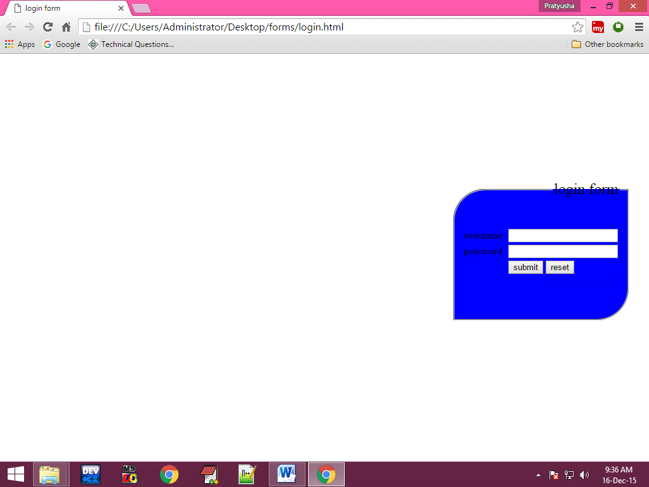

**Style Attribute:**

This is the common attribute for all the tags in html. In style attribute there are so many values are available some of them are…..

**Properties of the style attribute:**

**For Text:**

Text-align : center/left/right/justify;

Text-decoration : line-through/underline/overline/none;

Text-indent : number of pixels;

Text-transform : capitalize/lowercase/uppercase;

**For Borders:**

Border-color : colorname/colorvalue;

Border-left-color : colorname/colorvalue;

Border-right-color : colorname/colorvalue;

Border-top-color : colorname/colorvalue;

Border-bottom-color : colorname/colorvalue;

Border-style : solid/dashed/dotted/double/groove/etc;

Border-left-style: solid/dashed/dotted/double/groove/etc;

Border-right-style: solid/dashed/dotted/double/groove/etc;

Border-top-style: solid/dashed/dotted/double/groove/etc;

Border-bottom-style : solid/dashed/dotted/double/groove/etc;

Border-width : thin/thick/number of pixels/percentages;

Border-radius : in pixels;

Border-top-left-radius : in pixels;

Border-top-right-radius : in pixels;

Border-bottom-left-radius : in pixels;

Border-bottom-right-radius : in pixels;

**For Fonts:**

Color : colorname/colorvalue;

Font-style : italic/normal;

Font-family : verdena/Geneva/sans-serif;

Font-size : pixels/inches/em/cm/percentages/etc;

Font-weight : bold/normal;

**For Margins:**

Margin : pixels/inches/em/cm/percentages;

Margin-left : pixels/inches/em/cm/percentages;

Margin-right : pixels/inches/em/cm/percentages;

Margin-top : pixels/inches/em/cm/percentages;

Margin-bottom : pixels/inches/em/cm/percentages;

**For padding:**

Padding : pixels;

Padding-left : pixels;

Padding-right : pixels;

Padding-top : pixels;

Padding-bottom : pixels;

**For Spacing:**

Word-spacing : pixels;

Letter-spacing : pixels;

**For Background:**

Background-color : colorname/colorvalue;

Background-image : url(path of the image);

Background-position : left/right/center;

Background-repeat : no-repeat/repeat-x

(horizontal); repeat-y (vertical);

Background-attachment : fixed;

**For direction:**

Direction : ltr/rtl;

**For Display:**

Display : inline/block/none;

**For sizes:**

Height : number of pixels;

Width : number of pixels;

**For Position:**

Position : absolute/relative;

Left : number of pixels;

Right : number of pixels;

Top : number of pixels;

Bottom : number of pixels;

**For animation:**

Animation : animation name animation duration animation count

Animation-name :name of the animation

Animation-duration :time in millisec

Animation-direction :reverse,normal,alternate

Animation-delay :time in millisec

Animation-iteration-count :number of times;

Animation-play-state : running/paused

Animation-timing-function : linear/ease/ease-in/ease-out/ease-in-out;

**DHTML**

DHTML stands for dynamic hypertext markup language. This is used to create web pages using style sheets or performing dynamic actions on the static web pages.to do this we use following techniques.

* By using css
* By using javascript

**Css:**

Css stands for cascading style sheets.by using css we can apply the styles for the web pages. Here to apply styles for the html elements by using style sheets we have 3 types of style sheets.

They are:

1. Inline style sheets

2. Internal style sheets

3. External style sheets

**1. Inline style sheets:**

These are used to apply the styles for the specified tag in the webpage. These styles will applicable for only specified tag.

To apply inline style sheets we use style attribute.

**Syntax:**

<tagname style=”values”/>

**Example**:

<p style=”color:red”>any text</p>

**Pogram:**

**Example :1**

<html>

<head>

<title>inline styles</title>

</head>

<body>

<h1>heading 1</h1>

<h1 style="background-color:blue;width:200px;color:white">heading 1</h1>

<h1>heading1</h1>

<h1>heading1</h1>

</body>

</html>

**Output:**

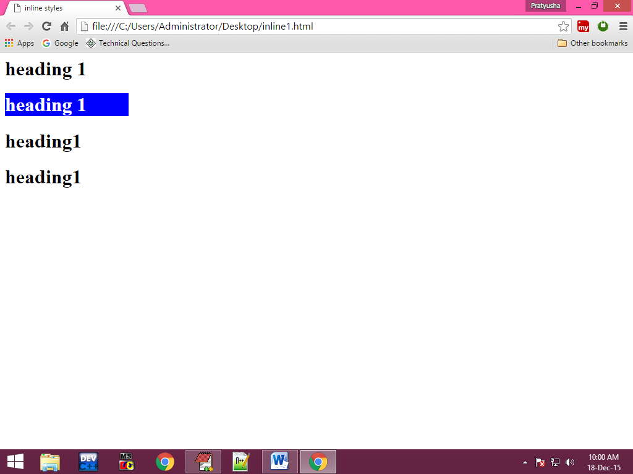

**Example :2**

<html>

<head>

<title> inline styles</title>

</head>

<body>

<p align="justify" style="word-spacing:10px;letter-spacing:2px;text-indent:20px;text-decoration:underline;font-style:italic;text-transform:small;background-color:blue;margin-left:30;margin-right:20px">

welcome to bdps this is my first web page welcome to bdps this is my first web page welcome to bdps this is my first web page welcome to bdps this is my first web page welcome to bdps this is my first web page welcome to bdps this is my first web page welcome to bdps this is my first web page welcome to bdps this is my first web page welcome to bdps this is my first web page welcome to bdps this is my first web page welcome to bdps this is my first web page welcome to bdps this is my first web page welcome to bdps this is my first web page welcome to bdps this is my first web page

</p>

<p align="justify">

welcome to bdps this is my first web page welcome to bdps this is my first web page welcome to bdps this is my first web page welcome to bdps this is my first web page welcome to bdps this is my first web page welcome to bdps this is my first web page welcome to bdps this is my first web page welcome to bdps this is my first web page welcome to bdps this is my first web page welcome to bdps this is my first web page welcome to bdps this is my first web page welcome to bdps this is my first web page welcome to bdps this is my first web page welcome to bdps this is my first web page welcome to bdps this is my first web page welcome to bdps this is my first web page

</p>

html<abbr style="text-decoration:underline">hypertext markup lang</abbr>

</body>

</html>

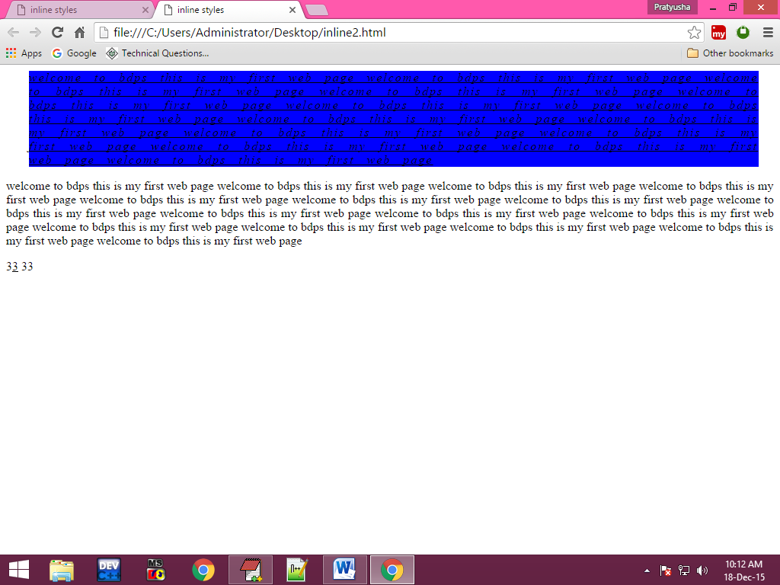**Output:**

**Example 3:**

<html>

<head>

<title>inline style </title>

</head>

<body>

<img src="E:\my html notes\my notes\html images\77.jpg" height="150" width="150" border="2" hspace="500" vspace="300" style="border-color:red;border-left-color:green;border-top-color:blue;border-left-width:5px;border-right-style:double;border-top-left-radius:40px;border-right-radius:50px">

</body>

</html>

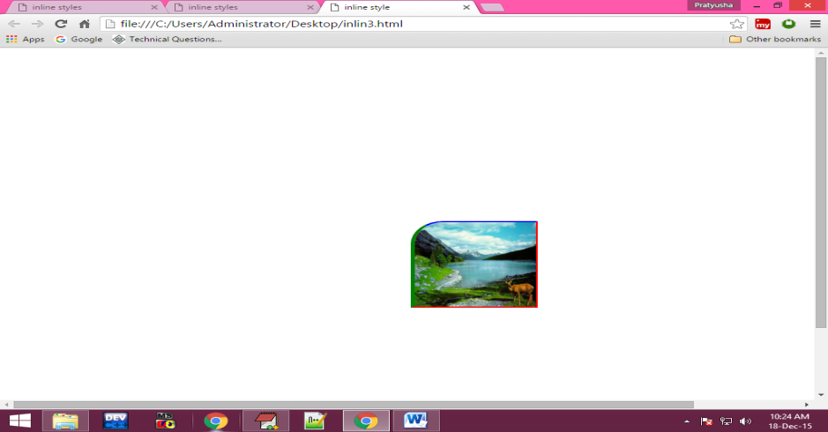**Output:**

**Example: 4**

<html>

<head>

<title>Inline Style Sheets</title>

</head>

<body>

<h1 align="center" style="font-size:80; color:orange; text-shadow:70px 50px 20px black">IRCTC</h1>

</body>

</html>

**Output:**



**Example: 5**

<html>

<head>

<title>inline style sheets</title>

</head>

<body>

<div style="height:200px;width:200px;border:solid;overflow:"auto\hidden\display">

EditPlus is a text editor, HTML editor, PHP editor and Java editor for Windows. While it can serve as a good Notepad replacement, it also offers many powerful features for Web page authors and programmers.

</div>

</body>

</html>

**Output:**

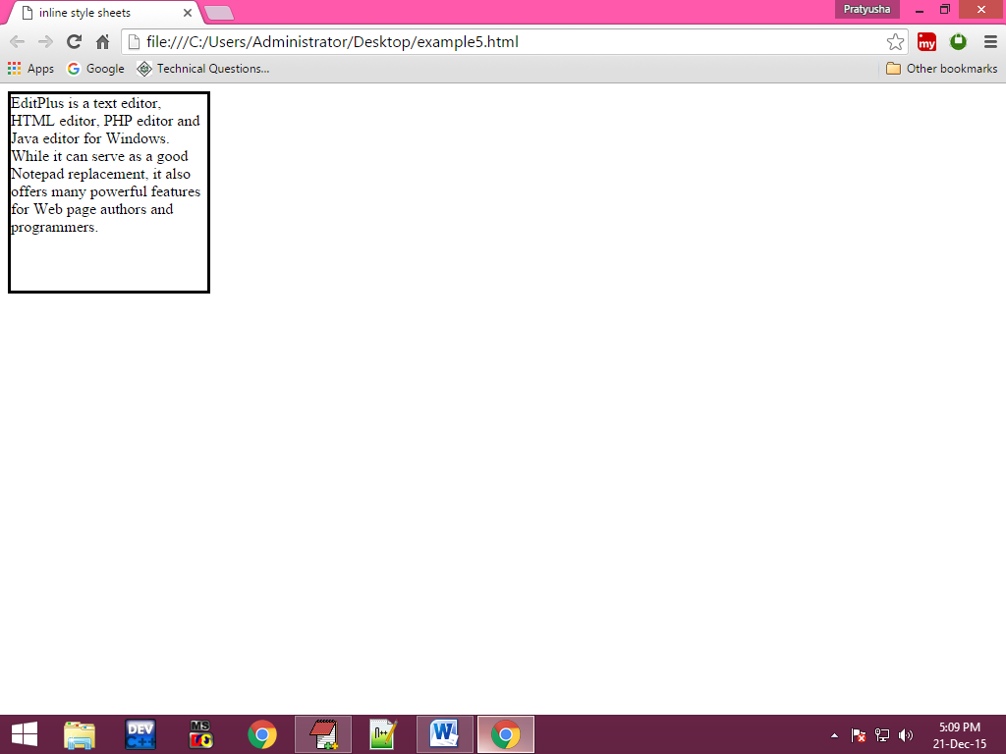

**Example :6**

<html>

<head>

<title>inline styles</title>

</head>

<body>

<div style="height:100;width:200;border:solid;color:green;font-size:20px;padding-left:30px;padding-top:50px;background:blue">

EditPlus is a text editor, HTML editor, PHP editor and Java editor for Windows. While it can serve as a good Notepad replacement, it also offers many powerful features for Web page authors and programmers.

</div>

</body>

</html>

**output:**

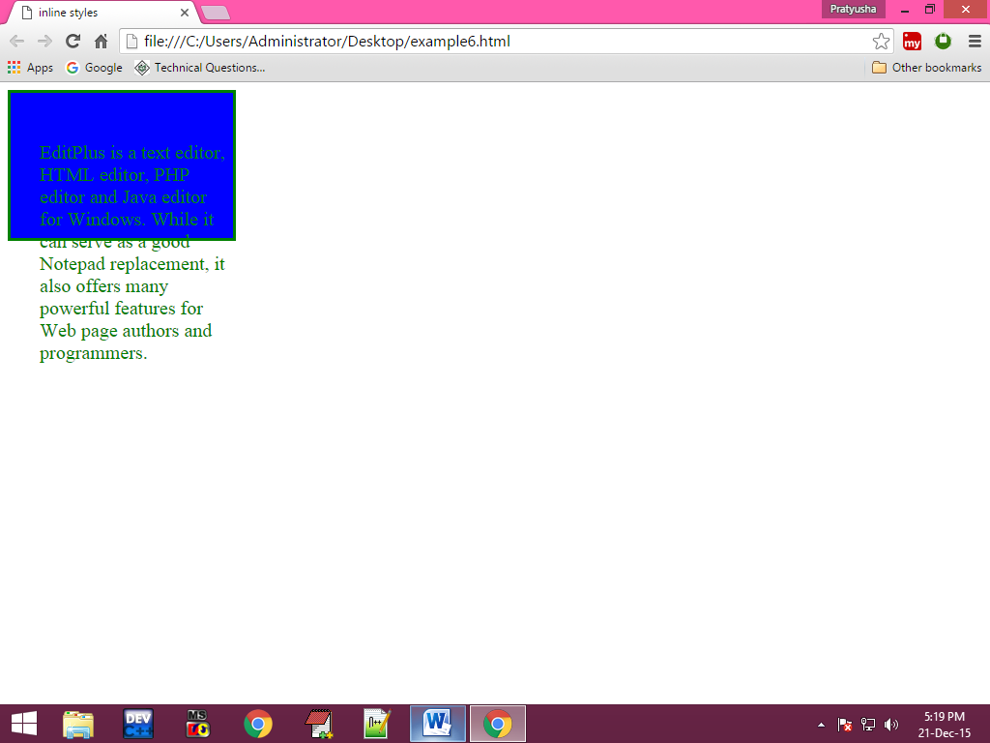

**Example : 7**

**<**html>

<head>

<title>inline style sheets</title>

<meta name="" content="width-device-width; initial-scale=1"/>

<body>

<table border="4" height="200" width="200" align="center">

<tr>

<td>1</td>

<td>abc</td>

<td>56</td>

</tr>

<tr bgcolor="gray" style="font-size:20px;text-align:center;font-style:italic">

<td>2</td>

<td>asp</td>

<td>89</td>

</tr>

</table>

</body>

</html>

**Output:**

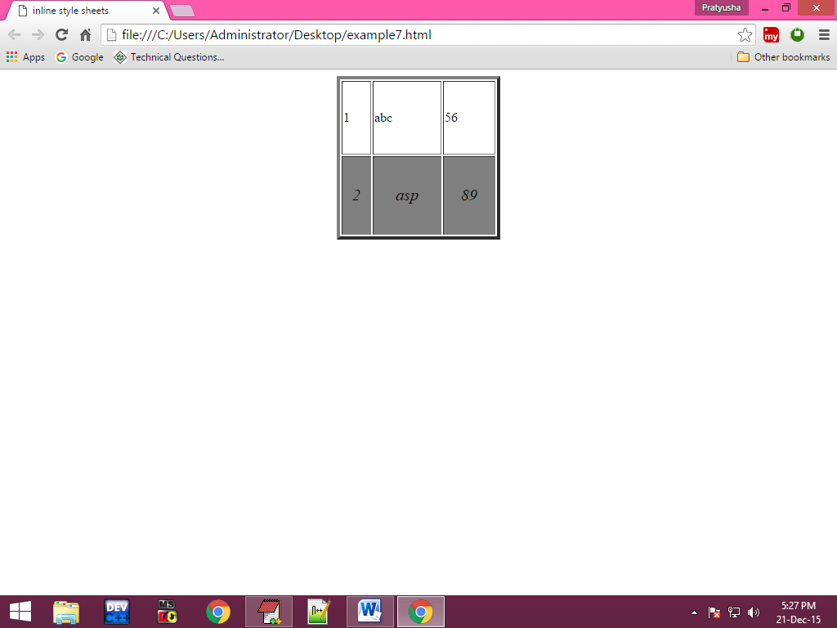

**Example 8:**

<html>

<head>

<title>inline style sheets</title>

</head>

<body>

name:<input type="text" style="background-color:red;height:30px;width:200px;border-top-left-radius:20px;border-bottom-left-radius:20px;color:white;font-size:20px"><br/>

password:<input type="password" style="background-color:red;height:30px;width:200px;border-top-left-radius:20px;border-bottom-left-radius:20px;color:white;font-size:20px">

</body>

</html>

**Output:**

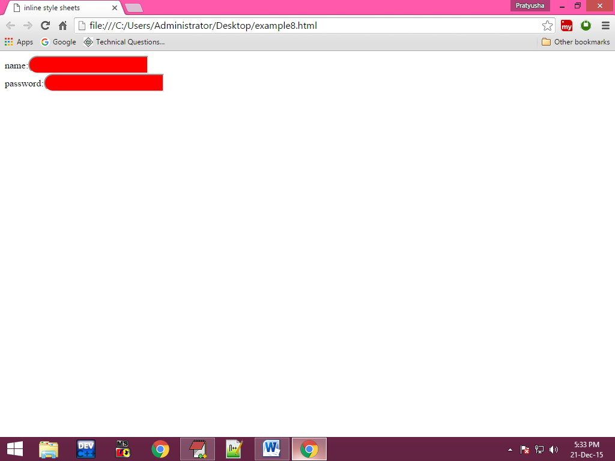

1. **Internal style sheets:**

These are used to apply the styles for specified tag in entire webpage. To apply internal style sheets we use style tag in html document. And internal styles are also called embedded style sheets.

**Selectors:**

Selectors are nothing but a pattern which are using to selects the html elements.

**Syntax:**

<style>

Selectors

{

Style value1;

Style value2;

---------------

---------------

}

</style>

In Internal Style Sheets we are using selectors. Here there are so many types of selectors are available some of them are

1. Generic Selector
2. Group Selector
3. Descendent Selector
4. Class Selector
5. Id Selector
6. **Generic selector:**

These type of selector can select only one html document.

**syntax:**

tagname

{

Style properties

}

1. **Group selector:**

Group selector can select more than one html at a time.

**Syntax:**

Tagname,tagname,

{

Style properties,

}

1. **descendent selector:**

Descendent selector can select the sub items.

**Syntax:**

Tagname1,tagname2

{

Style properties

}

1. **class selector:**

Class selector can group the style properties and it doesn’t select html document

**Syntax:**

.Classname {

Style properties

}

**Example:**

<tagname class= ”classname”>contents</tagname>

1. **id selector:**

Id selector can group the style properties and it doesn’t select any html document.

**Syntax:**

#id name

{

Style properties

}

**Example:**

<tagname id=”idname”>contents</tagname>

**Example: 1**

<html>

<head>

<title>internal style sheets</title>

<style>

h1

{

height:20px;

width:200px;

color:white;

background-color:blue;

}

h2,p

{

font-style:italic;

font-weight:normal;

font-size:20px;

}

</style>

</head>

<body>

<h1>BDPS</h1>

<h1 style="background-color-green">BDPS</h1>

<h2>welcome to bdps</h2>

<p>

EditPlus is a text editor, HTML editor, PHP editor and Java editor for Windows. While it can serve as a good Notepad replacement, it also offers many powerful features for Web page authors and programmers</p>

</body>

</html>

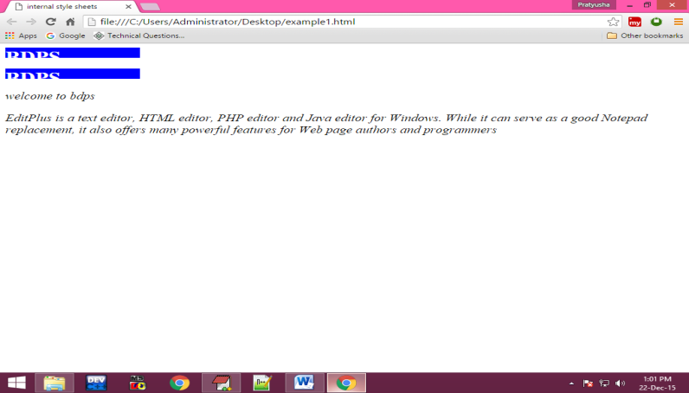**Output:**

**Example :2**

<html>

<head>

<title>internal style sheets</title>

<style>

div

{

height:150;

width:200;

border:solid;

overflow:auto;

transform:transform(300px,200px);

}

div:hover

{

background-color:rgba(255,0,0,0.3);

}

</style>

</head>

<body>

<div>

EditPlus is a text editor, HTML editor, PHP editor and Java editor for Windows. While it can serve as a good Notepad replacement, it also offers many powerful features for Web page authors and programmers.

</div>

</body>

</html>

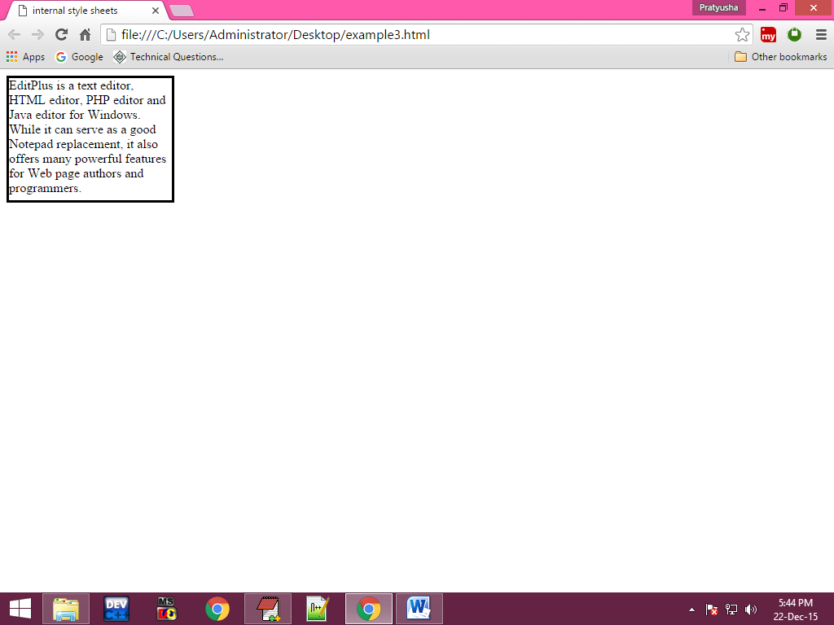**Output:**

**Example :4**

<html>

<head>

<title>internal style sheets</title>

<style>

#odd

{

background-color:wheat;

}

.even

{

background-color:blue;

}

.styles

{

font-size:20px;

text-align:center;

font-style:italic;

}

</style>

</head>

<body>

<table border="2" height="200" width="200" align="center">

<tr id="odd" class="styles">

<td>1</td>

<td>2</td>

<td>3</td>

</tr>

<tr class="even styles">

<td>1</td>

<td>2</td>

<td>3</td>

</tr>

<tr id="odd" class="styles">

<td>1</td>

<td>2</td>

<td>3</td>

</tr>

<tr class="even styles">

<td>1</td>

<td>2</td>

<td>3</td>

</tr>

</table>

</body>

</html>

**Output:**

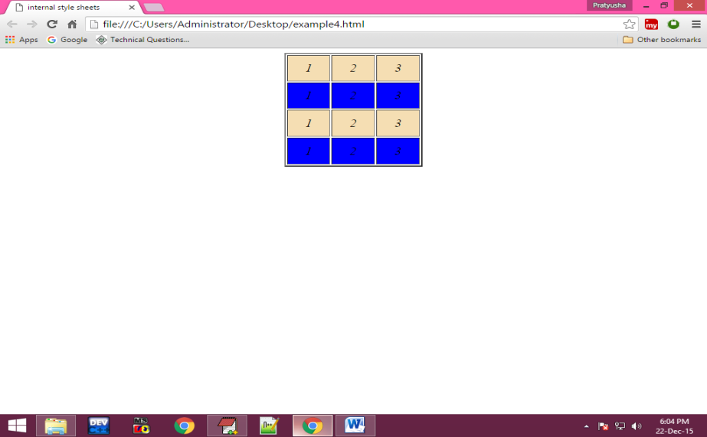

**Example: 5**

<html>

<head>

<title>internal style sheets</title>

<style>

.second li

{

font-size:20px;

display:inline;

}

</style>

</head>

<body>

<ol>

<li>Home</li>

<li>About</li>

<li>Contact</li>

<li>register</li>

<ol>

<ul class="second">

<li>Home</li>

<li>About</li>

<li>Contact</li>

<li>register</li>

</ul>

<ul>

<li>Home</li>

<li>About</li>

<li>Contact</li>

<li>register</li>

</ul>

<ul>

<li>Home</li>

<li>About</li>

<li>Contact</li>

<li>register</li>

</ul>

</body>

</html>

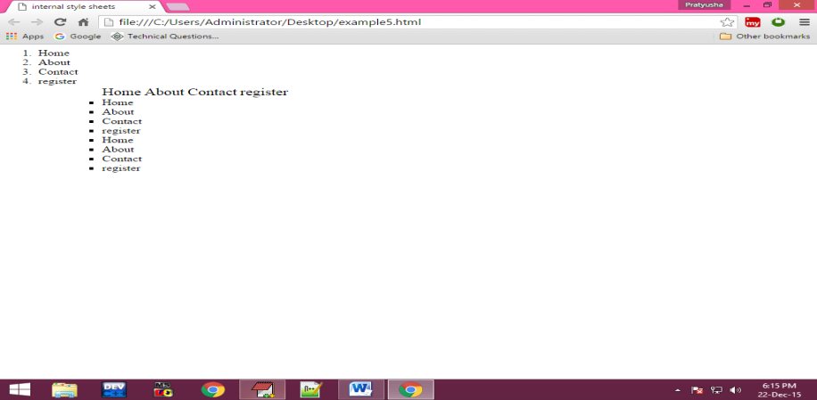**Output:**

**Example :6**

<html>

<head>

<title>internal style sheets</title>

<style>

#text1

{

position:absolute;

left:50px;

top:150px;

}

#il

{

box-shadow:5px 5px 5px black;

}

</style>

</head>

<body>

<div style="height:100px;width:100px;border:solid" id="il">

<img src="E:\my html notes\my notes\html images\2.jpg" height="200%" width="200%"/>

</div>

<div id="text1">

sample picture

</div>

</body>

</html>

**Output:**

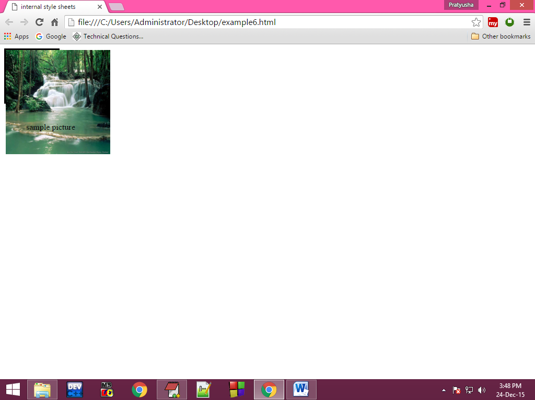

**Example :7**

<html>

<head>

<title>internl style sheets</title>

</head>

<body>

<div style="height:200px;width:200px;border:solid;position:absolute;right:30px;top:300px">

<div style="background-color:blue">

<p>chat</p>

</div>

<div style="background-color:gray;height:100px;overflow:auto">

<ul>

<li>1</li>

<li>2</li>

<li>3</li>

<li>4</li>

<li>5</li>

<li>6</li>

<li>7</li>

<li>8</li>

<li>9</li>

<li>10</li>

</ul>

</div>

</body>

</html>

**Output:**

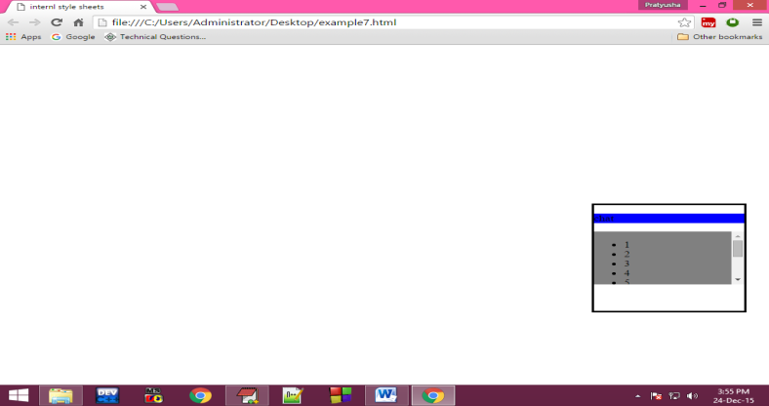

**Example 8:**

<html>

<head>

<title>internal style sheets</title>

<style>

#back

{

height:200px;

width:250px;

border:solid orange;

position:absolute;

left:300px;

top:100px;

background-color:red

}

#front

{

height:20;

width:20;

border:solid orange;

transform:rotate(45deg);

position:absolute;

left:480px;

top:90px;

background-color:orange;

}

</style>

</head>

<body>

<div id="front">

</div>

<div id="back">

welcome to web page

welcome to web pagewelcome to web page

</div>

</body>

</html>

**Output:**

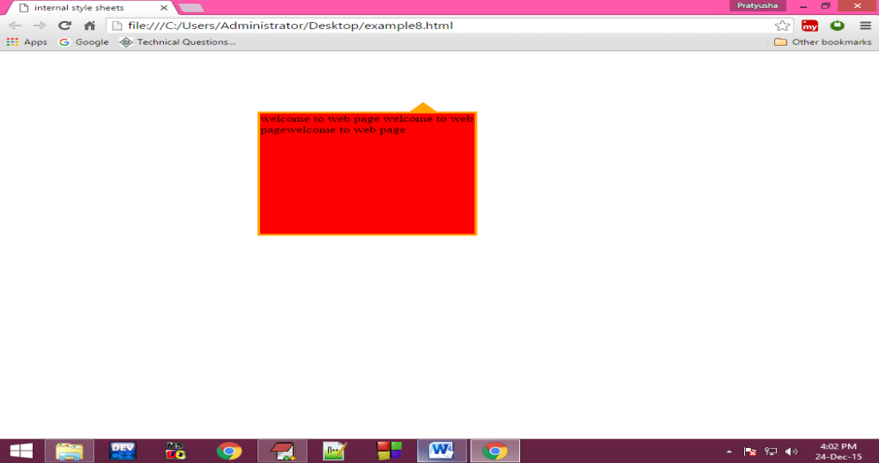  
**External style sheets:**

This is also used to apply the common style values in all the web pages then we use external style sheets. Here we can write the common style values in one css file and then use that css file in the html document.

To use css document we can use a tag ie; <link> tag.

**Attributes of the link tag:**

**Href:**

This attribute is to specify the destination css file.

**Syntax:**

Href=”path of the file”

**Rel:**

This attribute is used to specify the relation between css document and html document.

**Syntax:**

rel=”stylesheet”

**Types:**

By using this we can specify mime [multipurpose internet mail extension] type or internet media type.

**Syntax:**

<link href=”css file path” rel=”stylesheet” type=”text/css”/>

**Example:**

**Menu.html:**

**<**html>

<head>

<title>external style sheets</title>

</head>

<link href="menu.css" rel="stylesheet" type="text/css">

<body>

<center>

<ul>

<li><a href="#">file</a></li>

<li><a href="#">edit</a></li>

<li><a href="#">firstdocument</a></li>

<li><a href="#">search</a></li>

<li><a href="#">view</a></li>

<li><a href="#">project</a></li>

</ul>

</center>

</body>

</html>

**Main.css**

ul li

{

display:inline;

padding:60;

}

ul

{

background-color:black;

color:white;

padding-top:10;

height:30;

}

a:link

{

color:white;

text-decoration:none;

}

a:hover

{

background-color:orange;

padding:5;

}

a:active,visited

{

color:red;

font-size:25;

}

**Output:**

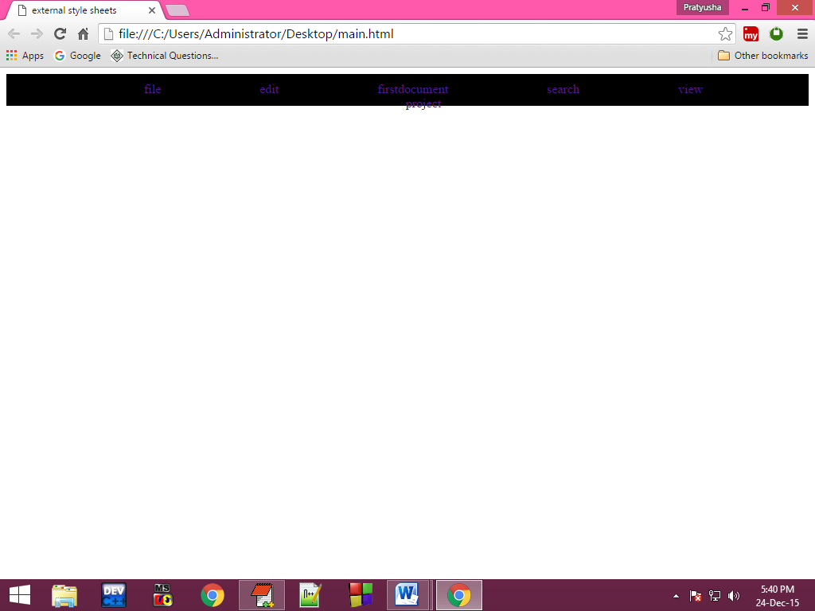

**Program:**

<html>

<head>

<title>animations</title>

<style>

div

{

height:75px;

width:100px;

border:solid;

animation:myanimation 10s;

-webkit-animation:second se 2;

}

@keyframes myanimation

{

from{background-color:red;}

to{background-color:gray:height:100px;width:200px;font-size:28px;}

}

@-webkit-keyframes second

{

from{background-color:blue;}

to{background-color:red;height:100px;width:200px;font-size:28px;}

}

</style>

</head>

<body>

<div>

my text

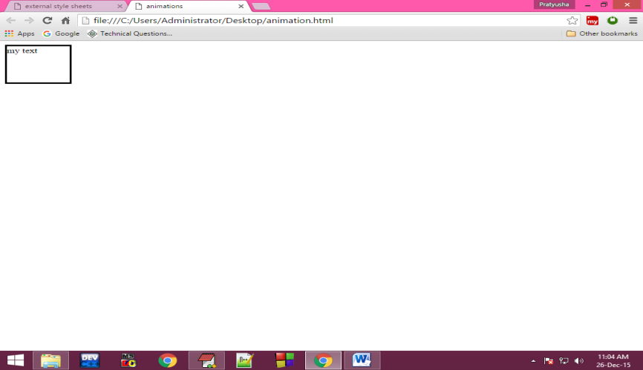</div>

</body>

</html>

**Output:**

**Meta tag**

Meta tags are HTML tags that provide information about a webpage's content to search engines and users. They play a crucial role in influencing how a website appears in search results and can impact click-through rate (CTR).

<meta name="description" content="Turn the algorithm into a friend.

The <meta> tag **defines metadata about an HTML document**. Metadata is data (information) about data. <meta> tags always go inside the <head> element, and are ...

‎Name - Attribute · ‎HTML meta content Attribute · ‎HTML meta charset Attribute ·